Edge Intelligence—  
On the Challenging   
Road to a Trillion Smart Connected IoT Devices

Moving Artificial Intelligence from the Cloud

Down to the Edge

|  |  |  |
| --- | --- | --- |
| **Ali Keshavarzi** | **Wilbert van den Hoek** | |
| Stanford University and Leading Edge Research | Leading Edge Research | |
| |  | | --- | | *Editor’s note:*  This article provides an industry and government perspective to the problem of intelligence resource-constrained IoT nodes and presents the vision of the future and important technologies that might play a strong role in enabling the vision of trillion smart connected sensors.  —*Shreyas Sen, Purdue University* | | | trillion connected devices a reality. The EI IoT device will be capable of sense, decide, act, and send. This will enable a wide range of new applications. The challenges that need to be |
| **EdgE IntEllIgEncE (EI),** the ability to analyze data at the point of data collection rather than sending it to the Cloud for analysis, will be a key enabler to realize a world of a trillion hyperconnected smart Internet-of-Things (IoT) devices. This article analyzes the need for cutting the umbilical cord to the Cloud and moving arti-ficial intelligence (AI) to the Edge, into the IoT device. The challenges of enabling the IoT sensor nodes to operate autonomously and sustainably in an environ-ment where energy is scarce and its supply is *intermit-tent* will be discussed. The benefits of providing local computing capability to create autonomous smart IoT devices are real-time processing and decision-making and improved data privacy while consuming less total | overcome for EI to live up to its full potential, including the development of new technologies, will be discussed. Among them are the concepts of *instant* computing and *intermittent* com-puting and their requirements, embedded non-vola-tile memory solutions, and a new class of low power electronics called *FerroElectronics*, along with heter-ogeneous integration using the system embedded in package (SeP) approach.We will discuss how combin-ing research on the topics of smart computing, com-munication, and technology will enable efficient, small next-generation AI systems for EI that can perform in-field learning and inference.  The phrase “Internet of Things (IoT)” started life as | |
| energy at the node as compared to communicating | the title of a presentation by Kevin Ashton at Procter & | |
| huge amounts of locally collected data to the Cloud | Gamble (P&G) in 1999 [1]. Ashton used this phrase to | |
| for analysis and analytics. EI is key to making a | identify radio frequency identification and sensor-tech- | |

nology-enabled computers that observe, identify, and

*Digital Object Identifier 10.1109/MDAT.2019.2899075*   
*Date of publication: 13 February 2019; date of current version:*

understand the world—without the limitations of human-entered data. Moreover, these computers

|  |  |  |  |
| --- | --- | --- | --- |
| *11 April 2019.* | communicate with each other via the Internet. | |  |
| **March/April 2019** | Copublished by the IEEE CEDA, IEEE CASS, IEEE SSCS, and TTTC | 2168-2356/19©2019 IEEE | 41 |

Authorized licensed use limited to: Georgia Institute of Technology. Downloaded on April 23,2021 at 20:05:39 UTC from IEEE Xplore. Restrictions apply.

SI: Intelligent Resource-Constrained Sensor Nodes

Around the same time, the thinking about Inter-net-connected devices took a dramatic step forward with the DARPA funded “Smart Dust” project at Berke-ley [2]. “Smart Dust” or “Mote” were defined as min-iature (less than a cubic millimeter in size) systems that are all around us and are capable of sensing, com-puting (including performing control functions), and

further use (analytics). The system typically has a bat-tery that provides the power. Such a system provides a bridge between the digital and physical domains. Intel-ligent cyber-physical system (CPS) for today’s data-cen-tric world should enable processing the sensed data locally to extract the information from the data to facil-itate more capable decision making and privacy [4].

communicating. In the last 20 years, academia as well as industry

Since then, IoT devices have become a part of everyday life, but they have remained relatively dumb and are reliant on the Cloud for intelligence. Similarly, in the early days (the 1950s until the late 1970s) of com-puting, dumb terminals were the gateway to mainframe computers. Just like the personal computer in the age of the PC enabled cutting the umbilical cord connec-tion with the mainframe computer, it is now the time to cut the umbilical cord between the dumb IoT device and the Cloud by making the IoT devices smart [3].

What is a dumb IoT device? At a very high-level view, a dumb wireless IoT device can be broken down into three components: 1) one or more sensors (temperature, pressure, image, etc.), 2) a microcon-troller, and 3) a preferred wireless [low-energy Blue-tooth (BLE), etc.] radio for communication with the Internet, or it can be a wired connection. The system is architected based on the traditional von Neumann architecture where the program or code is stored in the memory embedded in the microcontroller. Such a rel-atively simple system provides a path for an exchange between the physical and the cyberworld as shown in Figure 1. The sensor collects the data. The micro-controller converts these analog data into digital data using an analog-to-digital converter (ADC). The digital data are either processed by the microcontroller and are converted back to an analog signal using a digi-tal-to-analog converter (DAC) and then used to per-form a preprogrammed action (turn on a heater, water a plant, etc.), or the digital data are transmitted via the Internet to the Cloud where the data gets processed for

have been working to make the components that make up this dumb IoT device smaller, more powerful, less energy hungry, and wireless [3]–[7]. In parallel, thought leaders from the industry [8] and the leading institu-tions in academia have been exploring the vision of a trillion of these connected dumb IoT devices [3], [5]. Recently, it was Masayoshi Son, the CEO of Softbank in Japan, who took the vision one step further by making the suggestion to add artificial intelligence (AI) to this dumb IoT device and thus making it smart [9]. He artic-ulated that we will not only reach a trillion IoT devices, but, when we do, collectively, we will arrive at Singu-larity (Kurzweil [10]), at which point machine intelli-gence will be infinitely more powerful than all human intelligence combined. Masayoshi Son envisioned a Cambrian-like explosion when AI is combined with IoT (which he describes with the formula IoT × AI = Singu-larity). This perhaps means that by bringing AI to these trillion IoT devices, an unimaginably intelligent capa-bility is created resulting in Singularity. However, all these visions lack focus on the required details of what capabilities need to be developed to make this vision a reality. Especially the question “how can a smart IoT device operate in an environment where energy is scare, and its supply is *intermittent*?” has not been ade-quately addressed. As a result, the implementation and realization of this vision have not progressed as fast as could have been if the focus had been on what are the limiting factors and how can we eliminate them. The main challenge is that, today, several key technologies are missing to make this vision a reality.

|  |
| --- |
|  |

**Figure 1. Block diagram of a simple cyber-physical system (CPS).**

|  |  |
| --- | --- |
| 42 | **IEEE Design&Test** |

Authorized licensed use limited to: Georgia Institute of Technology. Downloaded on April 23,2021 at 20:05:39 UTC from IEEE Xplore. Restrictions apply.

Other than in Masayoshi Son’s vision, the IoT devices are typically seen to only “sense, maybe act and send” data. This limited communication-centric view has resulted in a variety of research programs, for example, to develop low-power small radios to serve a key need associated with the vision of 1 tril-lion IoT-connected sensors (and devices). These programs were based on the assumptions that the sensor-collected data would be sent to a central loca-tion for processing, the Cloud. However, the scala-bility of this approach is questionable. Ignoring for a moment the challenge of centrally processing the enormous deluge of data, applications requiring low latency, real-time conversion of data to information (e.g., braking in self-driving cars), privacy, security, and quality of service (QoS) are simply not ade-quately served by this Cloud-based approach.

In this article, the vision of Edge Intelligence (EI) is introduced. EI refers to a world where the raw data are converted into information locally at the point of sensor data collection (potentially including perform-ing local analytics), using energy-efficient computing, subsequently acting on this information and finally communicating the information to the Cloud (for larg-er-scale analytics). In the vision of EI, the dumb IoT device becomes smart, i.e., able to sense, decide, act, and inform (send), and will be able to cover a very wide range of applications [3]. In addition to pervasive com-mercial applications, EI could be used in swarmlike small and energy-efficient systems addressing DARPA’s vision of sensor fusion applications that are useful in the fields of aviation and defense, changing the paradigm from Sense-Communicate-Decide-Act to Sense-Decide-

|  |  |  |
| --- | --- | --- |
| |  |  | | --- | --- | | **Body**  Body and Brain Analogy | **Brain** | |

**Figure 2. IoT body and brain analogy.**

approaches for energy-efficient computing, all of which will be discussed in this article.

In summary, EI for the hyperconnected world of IoT is driven by the challenge of enabling the IoT sen-sor nodes to operate autonomously and to achieve self-sustainability in an environment where energy is scarce and its supply is *intermittent*. One reason to pro-vide local computing capability is the fact that the total energy consumed by the IoT device will be reduced with the right tradeoff between the energy used to per-form data reduction to information through local com-puting and the energy used to communicate the data to the Cloud. This will be explored in detail in this article. EI can provide a path in making a trillion connected devices a reality for a variety of applications. Several industry visionaries, including Wally Rhines, CEO of Mentor Graphics, have suggested that the IoT will be the next driver of the semiconductor industry growth [8]. This will only happen when EI becomes a reality.

|  |  |
| --- | --- |
| Act by using more advanced and faster processing of a large amount of sensory data in real time [11]. | The environment |

Thinking of EI IoT devices, an analogy with humans comes to mind. The sensors and actuators are the representations of the eyes, ears, arms, and legs and correspond to the body while computing, and local intelligence correspond to the brain, see Figure 2. In this analogy, the microcontroller in a dumb IoT

In this section, the environment in which smart IoT devices will operate and the challenges that need to be met to make the vision of a trillion of smart con-nected IoT devices a reality will be reviewed. So, what is standing in our way to reach this lofty goal of EI?

device corresponds to the autonomic nervous system Energy

in the human body, not the brain. The brain provides the intelligence, and the body does the sensing, actuating, and even some computing for local intel-ligence, hence achieving a level of autonomy [9].

Achieving the vision of a trillion smart IoT devices requires work on the brain portion, i.e., work on multiple research vectors covering energy- constraint

The environment of a trillion IoT devices is epito-mized by the scarcity of energy and the *intermittent* nature of the sources of this energy. Providing bat-teries for a trillion IoT devices and replacing them on a regular basis is neither practical nor feasible, not in the least because of the shortage of battery materials like lithium [12]. Instead, energy scaveng-

|  |  |  |  |  |  |
| --- | --- | --- | --- | --- | --- |
| systems | and | technology-assisted | algorithmic | ing and energy storage will be key approaches to |  |
| **March/April 2019** | |  |  |  | 43 |

Authorized licensed use limited to: Georgia Institute of Technology. Downloaded on April 23,2021 at 20:05:39 UTC from IEEE Xplore. Restrictions apply.

SI: Intelligent Resource-Constrained Sensor Nodes

providing energy to these devices. However, energy scavenging and storage alone will not be enough. *Intermittent* computing [3], [4], [13] will be required since the continuous availability of energy cannot

and security can be more easily guaranteed while reducing the energy needs of the devices.

This article does not cover the topic of security in depth. We have emphasized converting the data to

be guaranteed. information locally, which should be augmented by deploying hardware-based security measures (and Local autonomy root of trust). We should point out that conduct-

The conversion of data to information locally requires local computing as soon as the data become available followed by transmitting the information to

ing computing and converting data to information locally helps with privacy and security.

avoid large local data storage. Capable voltage-scaled Software

low-power advanced technology nodes where the amount of computing for a given energy budget is maximized are required to build these (multicore and many-core) processors [14], [15]. Therefore, in the context of this article, we will use the term *instant* computing. *Instant* computing is the evolution of low-power computing over the course of the last two decades using voltage-scaled advanced technology nodes, extending to a multicore processing architec-ture, marching toward many cores with specialized functions and hardware accelerators, and eventually to more technology-assisted algorithmic approaches that will be a subject of this article. Simply relying on legacy technology nodes and deploying subthreshold circuit designs and other special measures will not be adequate [3], [4], [16], [17].

Many applications require responsive local deci-sion-making [18] and, thus, real-time local computing. One of the reasons is that the required responsiveness does not allow latency associated with communica-tion with the Cloud for decision-making. Furthermore, in-field learning and self-learning are the critical capa-bilities that will alleviate the need for typical software resources dedicated to each application. Dedicated software resources will simply not be adequately available in the world of a trillion IoT devices. In-field learning requires a next wave of efficient algorithms and efficient systems that rely on *instant* computing and technology-assisted algorithmic approaches.

Data privacy and security

In the vision of the hyperconnected world of a tril-lion IoT devices, there will not be enough software engi-neers to write dedicated code for each device, nor will updating the software for these devices remotely [con-cept of over-the-air (OTA)] be acceptable. Instead, the need for efficient algorithms for inference and in-field learning such as reinforcement learning (RL) has to be addressed. We will need: 1) AI (by today’s machine learning or tomorrow’s more efficient algorithmic approaches that are closely linked to the technology capabilities and mapped into the structured data and architectures), 2) RL, and 3) self-learning for in-field learning to attain more autonomy. Furthermore, with the introduction of *intermittent* computing, real-time operating systems (RTOS) will neither be adequate nor be sufficient. New concepts for the operating sys-tem (OS) and the programing language for *intermittent* computing will have to be developed. This will add to the complexity of the vision of EI. Hardware and soft-ware for these extremely efficient systems will have to be cooptimized. This article does not dive deep into the topic of software and OS [13].

Integration and packaging   
 To meet the challenges identified in the “Energy” section through the “Software” section, heterogene-ous integration will be required [3], [19]–[24]. It is unlikely that all the hardware building blocks can be made on a single wafer using a common technol-ogy node. Silicon and nonsilicon substrates will be used for employing both bleeding-edge technology

|  |  |  |  |  |  |
| --- | --- | --- | --- | --- | --- |
| For | many | applications, | locally | collected | nodes for high-speed low-energy computing and less |

data are best secured by keeping that data local and not sending it to the Cloud. By conducting decision-making and intelligent inference, classi-fication, context detection, or analytics locally or by dramatically reducing the volume of data that needs to be transmitted through the conversion of the raw data into information locally, data privacy

advanced nodes for sensors, energy scavenging, and memory. Advanced and cost-effective 2.5-D fan- out packaging technologies will be required to create a system embedded in a package (SeP) [3], [4], [21]. In this article, we will address some of these key challenges in depth. Before we do that, let us look at a smart IoT device and identify its key components.

|  |  |
| --- | --- |
| 44 | **IEEE Design&Test** |

Authorized licensed use limited to: Georgia Institute of Technology. Downloaded on April 23,2021 at 20:05:39 UTC from IEEE Xplore. Restrictions apply.

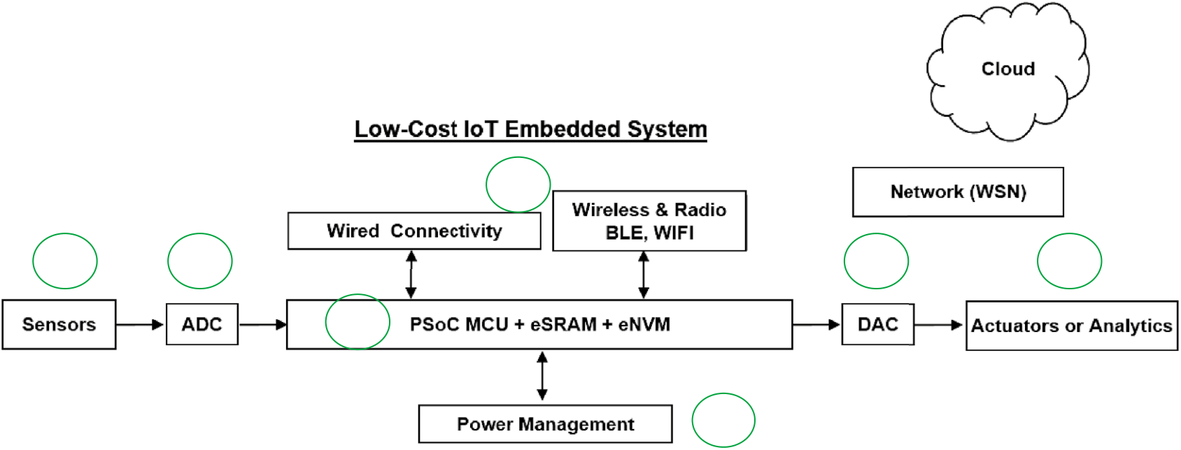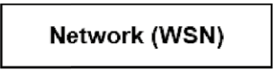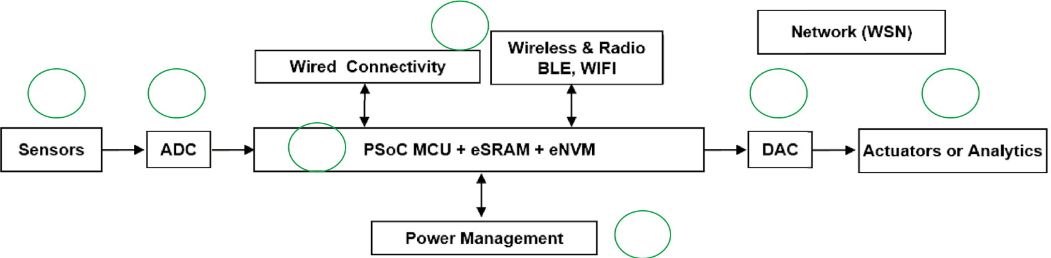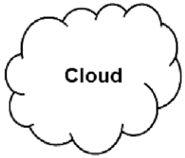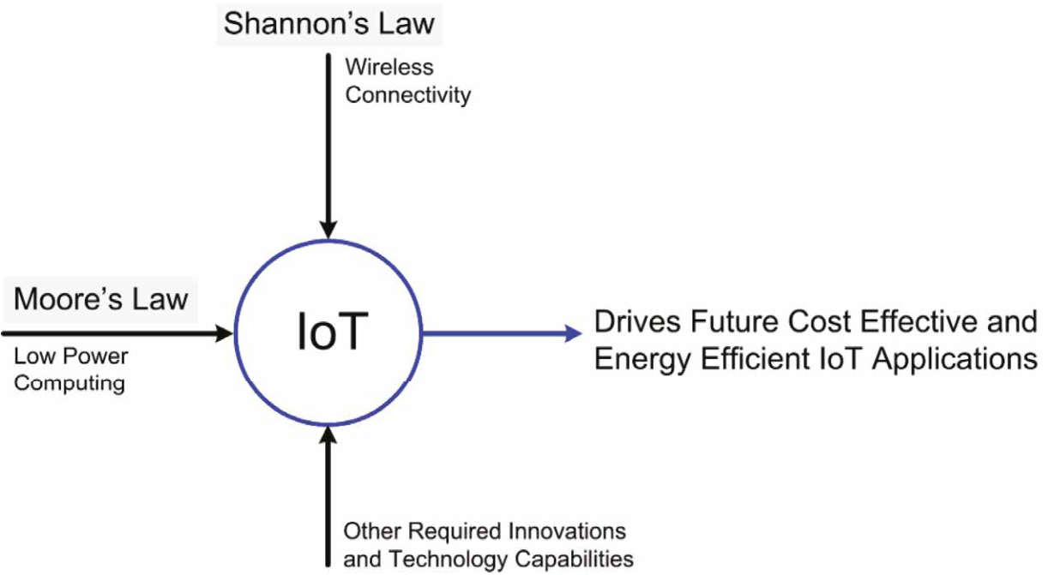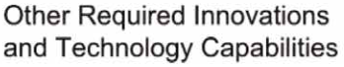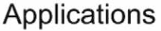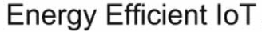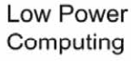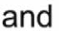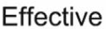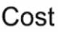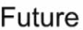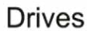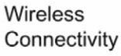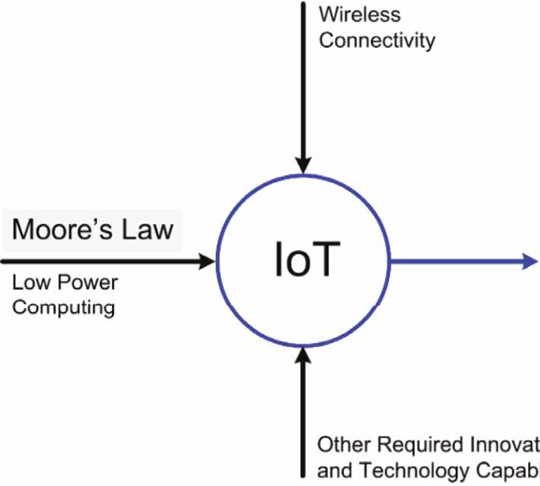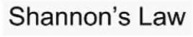

|  |  |  |  |  |
| --- | --- | --- | --- | --- |
| 6   |  |  |  |  | | --- | --- | --- | --- | | 1 | 2 | 5 | 4 |   3  7 |

**Figure 3. Today’s implementation of an IoT device for CPS based on the von Neumann architecture.**

What makes an IoT device smart?

Figure 3 shows an example of today’s implemen-tation of an IoT device. It is the capability to ana-lyze data using the processing unit (3) in Figure 3 that distinguishes a dumb from a smart IoT device. A smart EI IoT device typically incorporates (1) sen-sors that measure real-life information combined with (2) an ADC to convert the analog data from the real world collected by the sensors into digital data, (3) a processing unit and a variety of memory units of different types used in different stages of analyzing the sensed data and to learn and decide which action to take place. In the von Neumann architecture, these memory units include (a) non-volatile memory (NVM) to store data and keep the OS software plus the software program, (b) volatile memory (SRAM) to support the data pro-

scavenging energy, (b) storing energy, and (c) provid-ing energy to allow the system to operate.

In this article, we will first discuss how the energy consumed by the system can be minimized by mak-ing the right tradeoff between transmitting a reduced data set (i.e., information) resulting from local data processing and analysis and transmitting raw data to the Cloud for analysis. Next, we will show that having reduced the amount of data that needs to be transmitted dramatically through conversion of data into information, the system energy can be further reduced by utilizing new radio technologies optimized for minimal energy per bit transmission. Finally, we will focus on building block 3, the brain of the IoT device. We will show how this building block changes when the system migrates from a dumb IoT device to a smart IoT device (i.e., EI IoT device)

|  |  |  |
| --- | --- | --- |
| cessing by the processor, and (c) volatile [dynamic RAM (DRAM)] or NVM to store the results from the processing (4) actua-tors that implement the established action based on the decided response, combined with (5) a DAC to provide the analog signal to that actuator. (6) Connectivity function and subsystems that enable communica-tion between this IoT device and other devices or the Cloud through a network. Wireless communication is achieved by several means including via radios using either Bluetooth (or the BLE version), Wi-Fi, ZigBee, and 5G. Finally, the system requires a power management unit (7) with the following functions: (a) collecting/ | |  | | --- | | **Dennard’s:**  Dimensional scaling & Power  **Moore’s:**  Cost / Transistor & Economics |   **Figure 4. IoT is at the intersection of Moore’s Law and Shannon’s Law.** |

Authorized licensed use limited to: Georgia Institute of Technology. Downloaded on April 23,2021 at 20:05:39 UTC from IEEE Xplore. Restrictions apply.

SI: Intelligent Resource-Constrained Sensor Nodes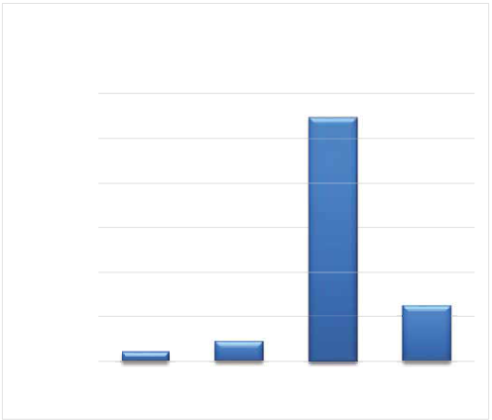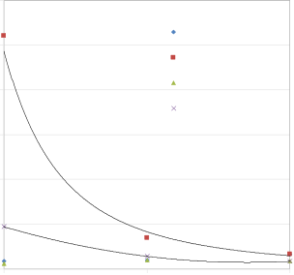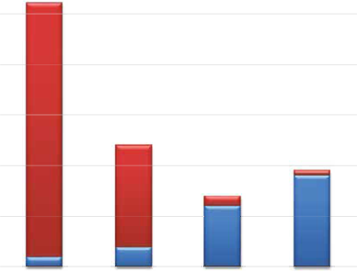

|  |  |  |  |  |  |  |  |  |  |  |  |  |  |  |  |  |  |  |  |  |  |  |  |  |  |  |  |  |  |  |  |  |  |  |  |  |  |  |  |  |  |  |  |  |  |  |  |  |  |  |  |  |  |  |  |  |  |  |  |  |  |  |  |  |  |  |  |  |  |  |  |  |  |  |  |  |  |  |  |  |  |  |  |  |  |  |  |  |  |  |  |  |  |  |  |  |  |  |  |  |  |  |  |  |  |  |  |  |  |  |  |  |  |  |  |  |  |  |  |  |  |  |  |  |  |  |  |  |  |  |  |  |  |  |  |  |  |  |  |  |  |  |  |  |  |  |  |  |  |  |  |  |  |  |  |  |  |  |  |  |  |  |  |  |  |  |  |  |  |  |  |  |  |  |  |  |  |  |  |  |  |  |  |  |  |  |  |  |  |  |  |  |  |  |  |  |  |  |  |  |  |  |  |  |  |  |  |  |  |  |  |  |  |  |  |  |  |  |  |  |  |  |  |  |  |  |  |  |  |  |  |  |  |  |  |  |  |  |  |
| --- | --- | --- | --- | --- | --- | --- | --- | --- | --- | --- | --- | --- | --- | --- | --- | --- | --- | --- | --- | --- | --- | --- | --- | --- | --- | --- | --- | --- | --- | --- | --- | --- | --- | --- | --- | --- | --- | --- | --- | --- | --- | --- | --- | --- | --- | --- | --- | --- | --- | --- | --- | --- | --- | --- | --- | --- | --- | --- | --- | --- | --- | --- | --- | --- | --- | --- | --- | --- | --- | --- | --- | --- | --- | --- | --- | --- | --- | --- | --- | --- | --- | --- | --- | --- | --- | --- | --- | --- | --- | --- | --- | --- | --- | --- | --- | --- | --- | --- | --- | --- | --- | --- | --- | --- | --- | --- | --- | --- | --- | --- | --- | --- | --- | --- | --- | --- | --- | --- | --- | --- | --- | --- | --- | --- | --- | --- | --- | --- | --- | --- | --- | --- | --- | --- | --- | --- | --- | --- | --- | --- | --- | --- | --- | --- | --- | --- | --- | --- | --- | --- | --- | --- | --- | --- | --- | --- | --- | --- | --- | --- | --- | --- | --- | --- | --- | --- | --- | --- | --- | --- | --- | --- | --- | --- | --- | --- | --- | --- | --- | --- | --- | --- | --- | --- | --- | --- | --- | --- | --- | --- | --- | --- | --- | --- | --- | --- | --- | --- | --- | --- | --- | --- | --- | --- | --- | --- | --- | --- | --- | --- | --- | --- | --- | --- | --- | --- | --- | --- | --- | --- | --- | --- | --- | --- | --- | --- | --- | --- | --- | --- | --- | --- | --- | --- | --- | --- | --- | --- | --- |
| |  |  |  |  |  |  |  |  |  |  |  |  |  |  |  |  |  | | --- | --- | --- | --- | --- | --- | --- | --- | --- | --- | --- | --- | --- | --- | --- | --- | --- | |  |  | **a.u.)** |  | **R** | **B** | **F** | |  |  |  | **)J** | **Total energy per frame for various** | | | | | | **compute and transmit condi�ons** | | | | | | **(** | **60** | | | | | | **e** | **m** | | **m** | |  |  | **m** |  |  |  |  | **( e** | **50** | | | | | | **a** | | **r F** | **m** | | a |  | **r** |  |  |  | b | **a** | **40** | | | | | | **e** | **rF r** | | **p** | **30** | | | | | | **e** | |  |  | **y** |  |  |  |  | **p y** | | **g** | | **r** | **20** | | | | | | **e** | **g r** | |  | c | **n** |  | **C** | **Algorithm 1** |  | **e** | **10** | | | | | | **E l** | **n** | | **E la** | | **a t** | | **o** | **t** | **0** | | | | | | **T** | **o T** | **1/I** | | **3/I** | **1/II** | **3/II** | | **Computa�on energy** | |  | **Transmission energy** | | | **)J** | **Computa�on Energy per Frame** | | | | | d | **Transmission Energy per Frame versus Computa�on Depth** | | | | | | **versus Computa�on Depth** | | | | | **60** | | | | | | **m** | **10 8 6 4 2 0** |  | | | | | **( e** | **)J** | **50** | | **40dB, 10e-8, Algo1** | | | **m** | **m (** | | **a** | **( e** | **70dB, 10e-8, Algo1** | | | **rF r e** | **m** | | **a r F** | **40**  **30** | | **40dB, 10e-4, Algo3** | | | **p y g r** | **r** | **70dB, 10e-4, Algo3** | | | **p y** | | **e** | **g r** |  | | | **n** | **e n** | | | | | | **E n** | **E n ois** | **20** | | | | | **oit** | | **Algorithm 2** | | **a** | **Algorithm 3** | **si** | | | | | | **t u** | **m s n a** | **10** | | | | | **p** | | **m** | **1** | | **2** | | **3** | **rT** | | | | | | **o** | **0** | | | | | | **C** | | **Computa�on Depth** | | | | | **1** | | | **3** | | | **Computa�on Depth** | | | | | |

**Figure 5. Computing and communication energy tradeoff for EI IoT devices [3], [11], [25]. (a) Qualitative analysis.**   
**(b)–(d) Quantitative analysis.**

data to information at the point of collection and subsequent transmission of that reduced data, is shown in Figure 5a. It describes the total energy used for an image-based or vision-based application (e.g., surveillance application). Computation and clever algo-rithmic approaches are required to do intel-ligent context detection locally, as well as for privacy and security.

In Figure 5a, the energy consumed by the processor required to extract the increasing lev-els of information from a raw image data, the energy used to transmit these different amounts of data resulting from the different levels of computation, and the sum of these two ener-gies are shown in a stacked bar graph. Commu-nication-centric transmission of the sensed data without much processing is represented by case “R” (representing raw data transmission). In this case “R,” the least amount of computing energy is consumed, but the largest amount of com-

and how the smart IoT device architecture will have munication energy is required since all the bits in the

to evolve from the von Neumann architecture and Turing machine for today’s less demanding appli-cations to alterative architecture when AI is to be deployed at the node using an EI IoT device.

Energy efficiency by trading transmission energy for computation energy   
 As described previously, today’s IoT devices emphasize communication since they typically trans-mit the sensed raw data without substantial data processing to the Cloud. Today’s IoT devices at most may deploy data-sampling techniques and may use limited processing to compress the data. This (data compression alone) is not the type of data processing required in our vision of EI. A key attribute of an EI IoT device is its ability to convert the data collected by its sensors to useful information locally. In addi-tion to adding value to the IoT device (at the edge) and reducing latency, this dramatically reduces the amount of the data that needs to be transmitted, the most energy consuming activity performed by the IoT device. In this section, the total energy needed for the device to operate will be explored. This brings us to the intersection of Moore’s Law and Shannon’s Law, as shown in Figure 4.

A qualitative representation of the energy con-sumption by an IoT device, when using different levels of data reduction and computation to convert

captured image need to be transmitted. Increasing the amount of computing such as in case “B” (conducting a background subtraction, i.e., comparing two sub-sequent images to see if anything has changed in the more recently captured image) results in an increase in the required computing energy. However, the required communication energy is dramatically reduced since the data of the more recent image is only transmitted if there is a difference in that image (as compared to the previous image). Feature extraction “F” and classifica-tion “C” are the functions that have traditionally been conducted in the Cloud and not at the edge as they require more computing capabilities than have been available at the edge. By enabling the feature extrac-tion or classification at the edge using energy-efficient computing, the total energy consumed by the IoT device can be reduced (significantly). The increase in computing energy is offset by a (larger) decrease in the communication energy. Future applications will seek even higher levels of autonomy demanding more efficient computing for in-field self-learning. Sys-tem energy optimization for a given application will depend on the technologies available for computing and transmission (communication).

The dynamic management of computing and com-munication energy use is essential for optimizing the total system energy use. A quantitative example for a vision system based on a system prototype published

|  |  |
| --- | --- |
| 46 | **IEEE Design&Test** |

Authorized licensed use limited to: Georgia Institute of Technology. Downloaded on April 23,2021 at 20:05:39 UTC from IEEE Xplore. Restrictions apply.

|  |  |  |
| --- | --- | --- |
| in [25] will be discussed next. In [25], the impact on | • | *Condition I:* Good channel with low (40 dB) path |

total energy consumption at the IoT device, accuracy, and QoS factors were quantitatively explored when trading off raw data communication (R) and Cloud-based data analysis with local data analysis combined with communication of a reduced data set to the Cloud. Energy-lean computing and context-aware communi-

loss, a high bit error rate (BER = 10−4), and a low-power data analysis algorithm (Algorithm 3) with maximum compression (an 8:1 compression), histogram of oriented gradients (HOG) feature extractor using three (lower end) gradients per feature, and application of a basic tree-based

|  |  |  |
| --- | --- | --- |
| cation were employed. The system is a video sensor | • | template algorithm. |
| capable of classifying human beings (i.e., detecting a | *Condition II:* Poor channel with high (70 dB) |

human being). The programmable system prototype uses a vision processing unit, a field programmable gate array and a software-defined radio (SDR). Neither an ASIC nor H/W accelerators were used in this sys-tem-leaving room for significant further optimization and energy reduction. Hence, in this analysis, we do not focus on the absolute values of the computation and transmission energy, but rather conduct a com-

path loss, a low BER (BER = 10−8) that needs to be maintained in this scenario of a lossy chan-nel and a high-accuracy data analysis algorithm (Algorithm 1) with the least compression (a 2:1 compression) of the acquired frame, HOG feature extractor using seven (higher end) gradients per feature and application of a more enhanced sup-port vector machine (SVM) classification tem-

parative analysis to extract valuable insights. plate algorithm.

The data processing ranges from baseline com-puting for raw data transmission to full local data analysis for classification (e.g., identifying a person in an image). The measured total energy (computa-tion + communication) per frame for a camera-based wireless sensor node (WSN) for surveillance applica-tions is shown for two types of designs.

The results show that for Condition II, with a high path-loss channel, by enabling feature extraction and classification at the edge using energy-efficient computing, the total energy consumed by the IoT device can be reduced by a factor of 4. In that case, the increase in computing energy is offset by a much larger decrease in the communication energy. It

|  |  |  |
| --- | --- | --- |
| • | *Design1* “Full-Transmission”: In this design, the | also shows that in the case of Condition I**,** where |
| the channel quality is good and the application only |
| sensor node performs only image acquisition, |
| requires low-accuracy data extraction tolerating a |
| localization, and compression, and then trans- |
| high BER, there is no energy benefit doing data pro- |
| mits the entire video data to the Cloud. Design 1 |
| • |
| cessing at the node, even though more than a thou- |
| shown in Figure 5b is similar to B in the qualita- |
| sand times (1000×) less data have to be transmitted |
| tive example shown in Figure 5a. |
| in Design 3 as compared to Design 1. Note that even |
| *Design 3* “Full-Computation”: In this design, the |
| if there is a small energy penalty associated with |
| sensor node performs all the tasks in the image |
| fully processing the data at the point of collection, |
| processing pipeline without considering the en- |
| there are other considerations like data privacy and |
| ergy cost of computation, independent of the |
| security which would most likely drive the user to |
| channel conditions. In the full-computation de- |
| accept a modest energy penalty to attain the high |
| sign (Design 3), object segmentation, compres- |
| level of date security and privacy associated with |
| sion, feature extraction, and classification are all |
| keeping the raw data at the point of collection. To |
| done locally at the sensor node. Design 3 shown |
| in Figure 5b is similar to C in the qualitative ex- | explore the details behind the tradeoff between |
| ample shown in Figure 5a. | raw data transmission (a communication centric |
| approach) and processing data at the point of col- |

Feature extraction F and classification C are the functions that have traditionally been conducted in the Cloud and not at the edge as they require more computing capabilities than was available at the edge, with advanced node processors that is no

lection, two additional figures (Figure 5c and d), extracted from the data in [25] are provided. In Figure 5c, the computation energy per frame is shown for three designs. Designs 1 and 3 were described above. Design 2 “Partial Computation”:

|  |  |
| --- | --- |
| longer the case.  In Figure 5b, the total energy results are shown for two sets of conditions. | Object segmentation, compression, and feature extraction are done at the sensor node. As expected, the computation energy per frame increases with |

Authorized licensed use limited to: Georgia Institute of Technology. Downloaded on April 23,2021 at 20:05:39 UTC from IEEE Xplore. Restrictions apply.

the increasing computation depth and with increasing accuracy of the employed algorithm. Algorithm 1 is the most accurate and Algorithm 3 is the least accurate but consumes the least amount of power. The increase in computation energy of 1.8 mJ employing the low-power Algorithm 3 for Design 3 versus Design 1 is not offset by a decrease in trans-mission energy, although the amount of data that needs to be transmitted is decreased 500× in Design 3, as can be seen in Figure 5d. This figure depicts the transmission energy per frame for the three designs, two algorithms, two channel path-loss conditions, and two BERs. The data show that in the case of a low path-loss channel (40 dB), the transmission energy per frame is independent of the computation depth, the type of algorithm used, and the desired BER. This is probably the result of the relatively high standby power of the chosen SDR. The picture is very different in the case of a high path-loss chan-nel (70 dB) which corresponds to real-life use cases: The transmission energy per frame dramatically increases from 3.3 mJ in the case of transmitting the fully processed data to 52 mJ (i.e., a 15× increase) when the 500× larger data are transmitted with a low BER (10−8) over this poor channel. Even when a high BER (10−4) and a low-accuracy algorithm are accept-able, in a high path-loss channel (70 dB), the 1.8-mJ increase in computation energy per frame is more than offset by a larger (7.7 mJ = 9.4 mJ − 1.7 mJ) increase in transmission energy per frame.

Analysis of data in [25], as shown in Figure 5, emphasizes that the communication should not be viewed by itself, but rather as a part of a complete sys-tem, that is, combined with the computing. Ideas for improving communication need to evolve from a sole emphasis on low-power radios, duty cycling, and the concept of smart-wake radios to implementing the for-ward-looking concept of intelligent communication. Context-aware and channel-adaptive communication [3], [25], [26] is important and its implementation leads to making communication intelligent. Smart computing combined with intelligent communica-tion will take us closer to the concept of IoT device autonomy required for EI. For example, we may want to capture the sensed data, perform computing on that data to reduce it to information and sequentially at a later time when the quality of the communication channel is good transmit the information.

This quantitative analysis example (based on data from [25]) explores the design space and shows that

optimization possibilities exist and pursuing a strategy of converting the data to information locally makes sense from a total energy consumption at the edge node point of view. The energy savings can be further improved by accumulating the processed informa-tion locally and transmitting only when the channel quality is good. Especially, in light of the observation that, in the case of a low path-loss channel, there is only a very weak relationship between the amount of data transmitted and the energy required to do this. Therefore, by employing this burst-mode trans-mission approach, there will be a total energy ben-efit in the case of full data processing at the point of collection even when a low path-loss channel is continually available. Something that is unlikely in the real world, that is, a 70-dB high path-loss channel is more representative of real-world condition. Note that burst-mode transmission will require a significant amount of (embedded) NVM with ultralow write and read energy per bit. This will be explored in the “*Inter-mittent* computing: The Need for Ultra-Low Energy eNVM” section. Note that the data in [25] are for a nonoptimized prototype system. As a result, the abso-lute values of the energies in this prototype system are relatively large because the hardware components were not optimized for this application. The Ga Tech system prototype [25] is capable of low rate of image processing which is useful in low fps applications. The larger computing capability and better energy efficiency needed for higher fps applications that will be required in the future will be addressed later in this article. In conclusion, better capabilities than those that are discussed in [25] are needed to realize more efficient local intelligence, making the vision of EI practical. System energy optimization for a given application will depend on the technologies available for computing and communication (transmission). Conceptually, this is the path to technology-enabled algorithmic energy-efficient computing and con-text-aware communication [3], [25], [26].

Next, we will review some of the recent develop-ments in making communication and computing more energy efficient. In the area of communication, key elements include the need for continual pro-gress in the fields of low-power radios, improved per-formance of radio duty-cycling to lower the energy in joule/bit, as well as the implementation of burst-mode communication (i.e., reduce data, aggregate, and communicate). Furthermore, new technologies and standards of 5G and NB-IoT will impact the

Authorized licensed use limited to: Georgia Institute of Technology. Downloaded on April 23,2021 at 20:05:39 UTC from IEEE Xplore. Restrictions apply.

connectivity of IoT devices toward more pervasive usage. Hence, this contributes to making the vision of a trillion connected devices a reality.

Researchers in the DARPA NZERO Program [27] have shown wake-up radios that require only nano-watt (nW) power to turn on another more capable radio in the system. However, operating the actual radio in the system frequently can cost an excessive amount of energy. Even the BLE radio consumes tens of milliwatts (consuming power for waking up and shutting down). Recently, startup compa-nies are trying to lower the BLE energy to single digit milliwatts [28], which is an improvement, but more communication energy reduction is needed. Forward-looking intelligent *intermittent* communica-tion with smart computing for smart IoT devices at the edge close to the data should be a critical topic for research. This links intelligent communication to the topic of *intermittent* computing and embedded NVM in this article. The end goal is to reduce the data to information at the point of data collection utilizing energy-efficient computing and combine extremely low-power wake-up radios with ultra-low-power infrequent burst transmission. The tradi-tional metric of energy for a radio is pJ/bit, but a new metric of pJ/information (energy per quantum of information that these smart radios will be inter-mittently transmitting) should drive the research. Some of these critical data used in our discussions regarding lowering pJ/bit are captured in Figure 6.

Not only has there been much research performed to improve the (energy) performance of radios, sim-ilar efforts have also been on going in the area of

|  |
| --- |
|  |

**Figure 6. Communication energy efficiency as a function of transmission distance. Energy-efficient radios (based on the metric of pJ/bit) are a critical part of the communication picture [26].**

energy-efficient computing [3], [25]. In fact, this area has been one of the major beneficiaries of Moore’s law-driven improvements (and Dennard’s scaling in years past). Using advanced technology nodes that operate at lower voltages continues to result in greater computing capabilities with improved performance and lower dynamic power consumption. The higher leakage power of these advanced technology nodes poses a challenge, which has led to the development of new leakage power management techniques [16], [17], [29]. The specific application will determine which process technology node is most suitable [30].

For example, Intel described an IoT device built on their advanced 14-nm technology node for a vision system used in agriculture applications [17], which relies on duty cycling with keen attention to power management techniques toward energy

|  |
| --- |
|  |

**Figure 7. IoT device for agriculture applications at the edge implemented in advanced 14-nm FinFET technology [17].**

Authorized licensed use limited to: Georgia Institute of Technology. Downloaded on April 23,2021 at 20:05:39 UTC from IEEE Xplore. Restrictions apply.

|  |  |  |  |  |  |
| --- | --- | --- | --- | --- | --- |
| **S** | **I2C** | **SOLAR CELL** | | | |
| **(1cm2)** | | | |
| **PMIC** | **HARVESTER** | | |
| **R** |
| **O** |
| **S** | **NTV MCU** | | **SPI** | **BLE** |
| **N** |
| **E** | **RADIO** |
| **S** |
| **SPI** | **UART** | | |
| **FLASH** | **SERIAL PORT** | | |

**Figure 8. Implementation of an IoT device in 14-nm FinFET technology, operating in a wide dynamic range allowing for a range of voltages and frequencies using best known low-power circuit techniques [14], [16].**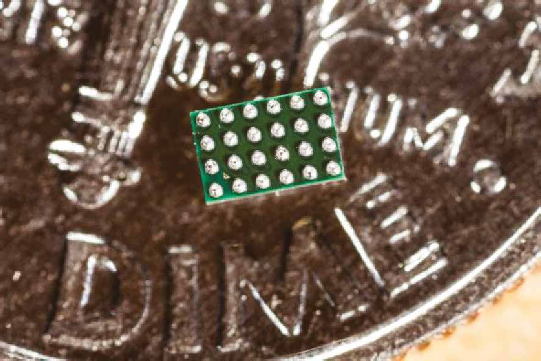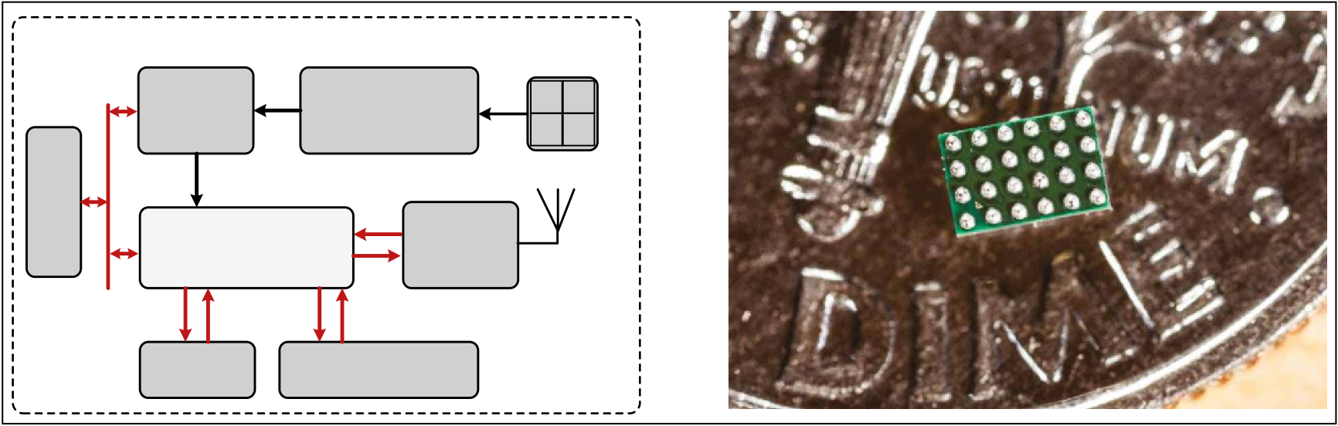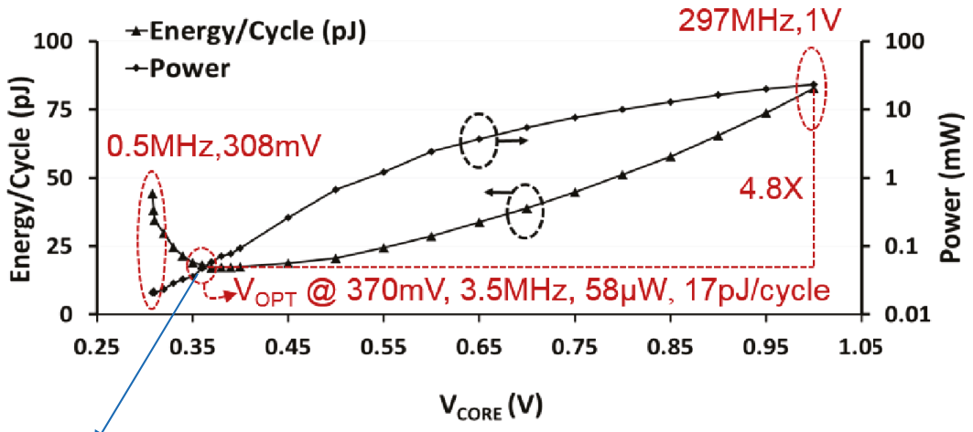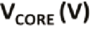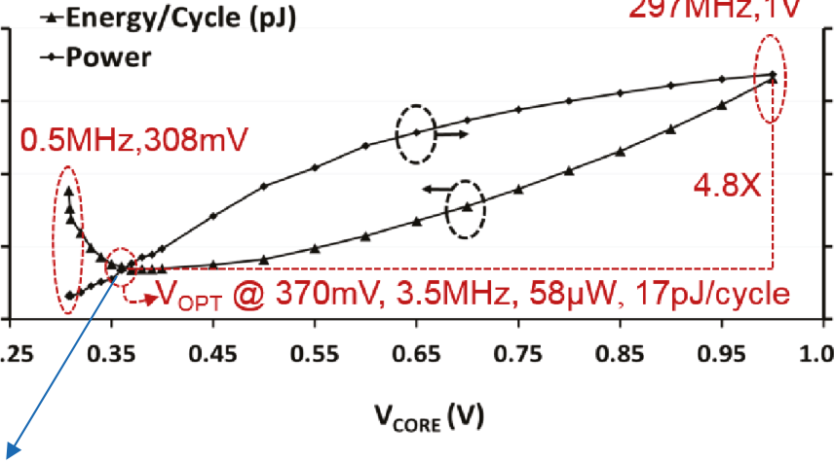

autonomy by using various energy-scavenging methods. The system uses a highly integrated

four independent voltage frequency islands. The best known low-power circuit techniques have been

SoC and when operating at 0.4 V achieves 80-µW deployed [14].

power consumption at a 200-kHz operating fre- This system consumed 360 µW when operating

quency (Figure 7). at 0.45 V and a 13-MHz operating frequency. The

In [16], Intel showed another IoT device (or what they referred to as a wireless sensor node (WSN) for edge computing) built using their 14-nm Fin-FET technology with a system operating in a wide dynamic range allowing for a range of voltages and frequencies (Figure 8). A small 0.79 mm2 IA-32 core provided the edge computing capability that could operate at near threshold voltage and intentionally not in the subthreshold region to avoid variability and susceptibility to yield issues while deploying

|  |
| --- |
| MEP = Minimum Energy Point |

**Figure 9. Performance, power, and energy of the**   
**“X”PU [microcontroller unit (MCU) or central process-ing unit or processing element] of Figure 8, showing MEP and NVT (near *V*t voltage operation) [16] with fun-damentals of low-energy computing, advanced nodes, lower voltage, and NTV while deploying best known low-power circuit design techniques [14], [16].**

minimum energy point (MEP) was reached at 0.37 V, which is at a lower voltage than the quoted 0.45-V operating voltage. Operating at the MEP of 0.37 V allows for 3.5-MHz operating frequency at a power of 58 µW, resulting in a minimum energy of 17 µW/MHz (Figure 9).

These examples show what is available in terms of lower energy computation, toward enabling *instant* computing on advanced nodes. Qualcomm has also reported the results in the same field [31]. These implementations are improvements in lowering power. However, these examples as well as today’s mobile phones operating at > 1 W, edge comput-ing devices for self-driving cars operating at > 10 W, and surveillance systems that are still operating in the range of > 100’s of µW to 10’s of mW, perform nowhere near the desired goal of 1 µW. Therefore, the capability and efficiency of computing have to be improved dramatically, which will require more technology-tuned algorithmic computing tech-niques, to realize efficient *instant* computing.

Finding the optimum point between data pro-cessing and data communication and employing efficient *instant* computing are still not enough to overcome the energy challenges of an EI IoT device. Pervasive and capable EI IoT devices will be lim-ited by the *intermittent* availability of scarce energy caused by the discontinuous nature of the availa-ble tiny sources of energy. As a result, *Intermittent*

Authorized licensed use limited to: Georgia Institute of Technology. Downloaded on April 23,2021 at 20:05:39 UTC from IEEE Xplore. Restrictions apply.

|  |  |  |
| --- | --- | --- |
| |  |  | | --- | --- | | E1: Power On  E2: Low Energy  Stop Computing  Check-Pointing  E3: Power Off |  | |

**Figure 10. Temporal energy consumption for *intermittent* computing [3], [4].**

computing will be required. It is a form of comput-ing where the computation is performed at irregular intervals, only when energy is available. (This may be viewed as a form of burst computing driven by availability of energy.) As a result, the state of the computing machine has to be saved in NVM before the energy runs out in order to be able to continue the computing when energy becomes available again. Let us discuss the *intermittent* computing in

also help the communication (radio and transmit) aspects of the system by enabling duty cycling of the radio by accumulating processed information and then transmitting information in burst mode (aggre-gate and communicate at the right *instant* and time toward more intelligent communication), preferably when low-loss communication channel is available.

There are other challenges that are not covered in this article. For example, power management,

detail in the following section. energy scavenging, and energy storage are critical

*Intermittent* computing: The need for ultralow energy eNVM

*Intermittent*computing requires an embedded

NVM (eNVM) solution on advanced technology

for *intermittent* computing in EI. Batteries are not the answer for the pervasive IoT applications that we have in mind, since there will not be enough battery material [3], [12]. Capable MEMS technology that enables the required low-energy sensors and actua-

nodes with desired low write energy and a relatively tors is equally important.

high to high endurance (application dependent) and a modest level of data retention for the dura-tion that the system lacks energy [3]. The concept of

eNVM plays an enabling role in *intermittent* computing. In the following section, the eNVM solu-tions are reviewed and some application examples

*intermittent* computing is shown in Figure 10. are discussed.

Reliable software (S/W) is critical for the system as the S/W has to deal with control flow, check-point-ing, states, concurrence, and data consistency which are challenges by themselves. New software, OS, and Programing Language are needed [13]. An EI system benefits from energy scavenging using, for example, solar cells as shown in the agriculture example below [4] and supercapacitors for storage. The combination of energy scavenging and storage

The table shown in Figure 11 compares the key attributes of different types of memory used in IoT devices. It focuses on eNVM and, for reference, also shows stand-alone NVM, eSRAM, and stand-alone DRAM. The eNVM multibit per cell program/ write capability column is relevant for analog and in-memory computing is discussed later in this arti-cle. The endurance versus retention tradeoff in the design of spin transfer torque (STT)-RAM makes

is an enabler for EI systems. their endurance low in eNVM application. Resistive

eNVM is critical for *intermittent* computing, and *intermittent* computing is key for EI. eNVM will

random access memory (RRAM) suffers from non-symmetric conductance.

Authorized licensed use limited to: Georgia Institute of Technology. Downloaded on April 23,2021 at 20:05:39 UTC from IEEE Xplore. Restrictions apply.

|  |  |  |  |  |  |  |  |  |  |  |  |  |  |  |  |  |  |  |  |  |  |  |  |  |  |  |  |  |  |  |  |  |  |  |  |  |  |  |  |  |  |  |  |  |  |  |  |  |  |  |  |  |  |  |  |  |  |  |  |  |
| --- | --- | --- | --- | --- | --- | --- | --- | --- | --- | --- | --- | --- | --- | --- | --- | --- | --- | --- | --- | --- | --- | --- | --- | --- | --- | --- | --- | --- | --- | --- | --- | --- | --- | --- | --- | --- | --- | --- | --- | --- | --- | --- | --- | --- | --- | --- | --- | --- | --- | --- | --- | --- | --- | --- | --- | --- | --- | --- | --- | --- |
| |  |  |  |  |  | | --- | --- | --- | --- | --- | | **Non-Volatile** | **Energy / bit** | **Speed** | **Endurance** | **Multi Bit/Cell** | | SONOS | 1-10 pJ | us | 105-106 | Yes | | FG eFLash | > 100 pJ | us | 104 | No | | STT-MRAM | ~ 10 pJ | 10-100 ns | 106-107 | No | | RRAM | > 10 pJ | 10-1000 ns | 104-105 | Yes | | PCM | 10-100 pJ | 10-100 ns | 106-107 | Maybe | | PZT-based FRAM | 0.1-1 pJ | 100 ns | Large 1014 | No | | FE-based FEFET | ~ 10 fJ | ~ 10 ns | Research 105 | Yes | | FEMFET IEDM 2018 | ~ 100 fJ | < 100 ns | > 1010 | Yes |  |  |  |  |  |  | | --- | --- | --- | --- | --- | | Flash | 100’s nJ | ms | 104 | Y | | eSRAM | 0.1 pJ | ns | Very Large | Y | | DRAM | 10’s of pJ | 100 ns | Large | Y |   Other Parameters: Scalability, Retention, Voltage, Leakage, Cell Size, Area, Masks, ECC …Note that SONOS does not need ECC |

**Figure 11. Comparison table for various (embedded) memories used in IoT devices.**

Today, the most commonly used eNVM is floating gate embedded Flash (FG eFlash). It was available at the 180-nm node and is still the main solution at the 40-nm node. This is forecasted to change at the 28-nm node where embedded magnetic ran-dom access memory (MRAM) based on STT is forecasted to be introduced. However, it is unclear whether eSTT MRAM will scale much beyond the 28-nm node. Other emerging eNVMssuch as RRAM, phase change memory (PCM), and carbon

nanotube (CNT) memories continue to be in the research and development stage and have issues with energy consumption, variability, symmetry (of conductance in write and erase), and/or cell size.

It is the opinion of the authors that neither FG eFlash nor embedded spin transfer torque (eSTT) MRAM are the right choice for IoT devices for capa-ble EI systems operating in an environment where energy is scarce and its supply *intermittent*. Instead, at 28 nm and above, semiconductor-oxide-nitride-ox-ide-semiconductor (SONOS) is the preferred choice based on cost and write energy. At the 130-nm node, lead zirconate titanate (PZT)-based ferroelectric ran-dom access memory (FRAM) is also available, but this solution is not scalable to more advance nodes.

Semiconductor-Oxide-Nitride-Oxide-Semicon-ductor (SONOS), one of the charged based eNVM solutions, is shown in Figure 12. It should be men-tioned that the SONOS structure is also commonly used in vertical 3-D nand flash devices for solid-state storage. SONOS memory devices are relatively low-voltage charged-based eNVM that work by trap-ping electrons/holes in the nitride layer of the oxide nitride oxide (ONO) stack in the gate of the transis-tor. A robust SONOS memory cell uses a 2T (2-transis-tor) configuration where one transistor serves as the access transistor (control gate [CG]) and the other is the SONOS charge storage transistor (SONOS gate or SG). The SONOS 2T cell area is about 50F2. The write and erase function of SONOS memory cells

|  |
| --- |
|  |

**Figure 12. SONOS charge-based NVM basics [3].**

Authorized licensed use limited to: Georgia Institute of Technology. Downloaded on April 23,2021 at 20:05:39 UTC from IEEE Xplore. Restrictions apply.

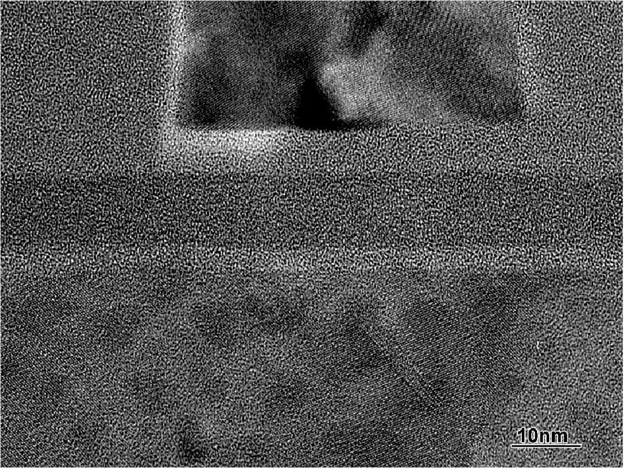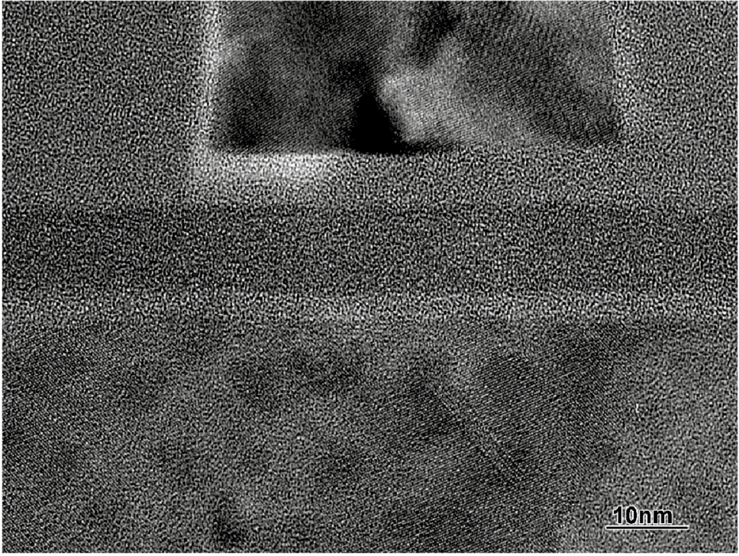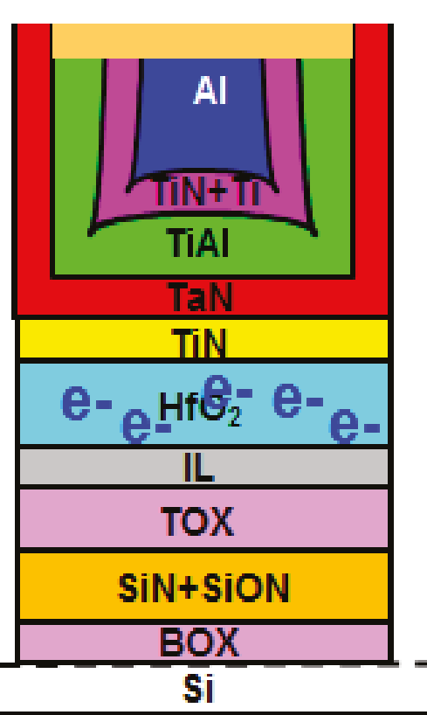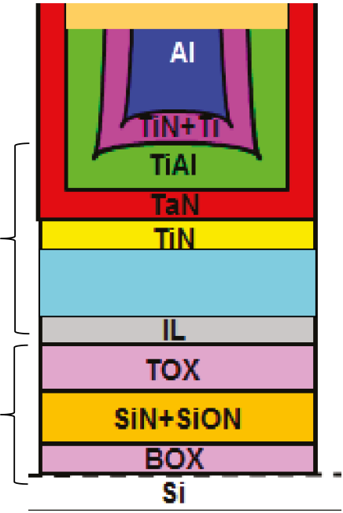

|  |  |  |  |  |
| --- | --- | --- | --- | --- |
| *(S) - Gate*  *(O) - Blocking Oxide*   |  |  |  | | --- | --- | --- | | *(N) - Silicon Nitride* | HKMG | **HfO2** | | *(O) - Tunnel Oxide* |   *(S) - Channel Silicon*   ONO |

**Figure 13. Scalability of SONOS to 28-nm HKMG CMOS. SONOS can be integrated in 28-nm HKMG CMOS and future FinFET technologies [3], [4].**

are based on Fowler–Nordheim (FN) tunneling (a quantum mechanical tunneling). FN tunneling is used for programing and erasing the SG device of the memory cell. The threshold voltage (*V*t) of the SG transistor device changes based on adding or subtracting electrons from the nitride layer in the

The vertical 3-D nand SONOS is already integrated with HKMG. It should be pointed out that advanced technology nodes, which use HKMG, are needed for *instant* computing and EI. These nodes do not have polysilicon which is needed for the FG eNVM alter-native. SONOS works and can be integrated with

ONO stack (Figure 12). HKMG (Figure 13). SONOS operates at low voltage in

SONOS is a capable eNVM solution in today’s pro-duction technology nodes. It is low cost because it uses 5 additional masks as compared to 13+ masks used in the case of the widely available FG alterna-tive charge trap eNVM. Also, note that the FG eNVM (or FG eFlash) stores charge on the polysilicon gate, referred to as the FG. In the advanced technology nodes needed for EI applications, polysilicon will not be easily available as these technologies are high-K dielectric and metal gate (HKMG)-based. The polysil-icon gate is replaced with a metal gate. Therefore, the cost of adding FG eNVM will be even higher at these advanced nodes, making it an economically unattrac-

the range of 5–7 V compared to 12–13 V in the case of FG eNVM. In addition to the energy benefits of this lower operating voltage, the reliability (as well as the yield) is better because of the gentler FN-tunneling mechanism for program and erase at lower voltage. The overall memory macro area is smaller as the area for the high-voltage periphery devices will be smaller for SONOS eNVM. SONOS is also compatible with the commonly used three gate oxide flow (e.g., in 40-nm technology node) which can provide even smaller periphery and yet more compact macros.

Despite SONOS’ benefits of portability to advanced nodes, low cost, and ease of integration

tive solution. (embedding in the advanced CMOS technology)

SONOS, however, can be easily added at a low cost to HKMG technology nodes as well as FinFET technology nodes [3], [4]. Renesas, who calls its SONOS technology Split-Gate-Metal-Ox-ide-Nitride-Oxide-Semiconductor (SG MONOS), is extending this technology to the 16-nm node [32]. Toshiba, Samsung, and Hynix are using SONOS in

making it an *intermittent* computing enabler, it is not a main offering on today’s leading edge-scaled technology nodes at foundries. It is mainly a cus-tom technology solution at foundries available only for certain companies like Renesas and Cypress Semiconductor who transferred their SONOS tech-nology to these foundries. Therefore, SONOS is not

their stand-alone 3-D nand which is not an eNVM, widely adopted.

but is produced in very large volume for SSDs, attest-ing to the production worthiness of the technology.

To demonstrate the capabilities of a SONOS eNVM-based IoT device, a system for precision

Authorized licensed use limited to: Georgia Institute of Technology. Downloaded on April 23,2021 at 20:05:39 UTC from IEEE Xplore. Restrictions apply.

**Server &**   
**Cloud**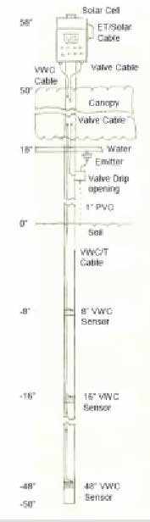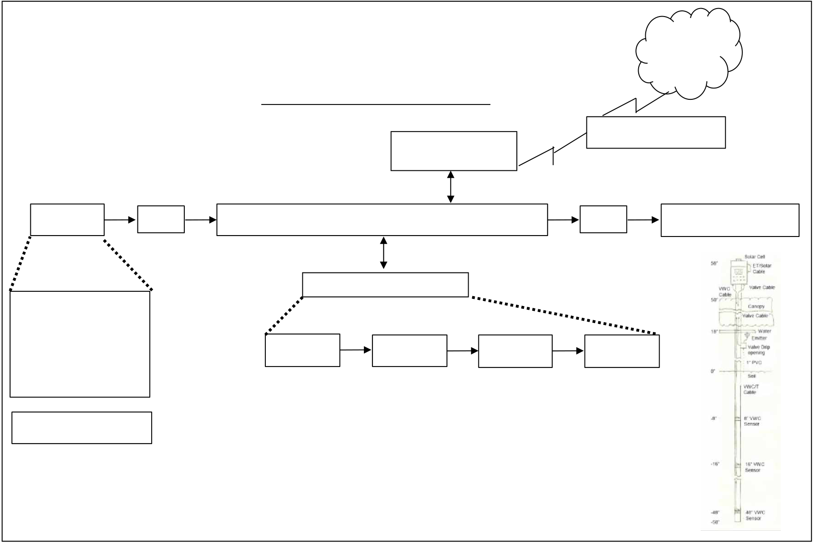

**Irrigation IoT Embedded System**

|  |  |  |  |  |
| --- | --- | --- | --- | --- |
| In-sensor ADC and processing | | **Wireless Radio**  **BLE** | **Gateway & Network** | |
| **Sensors** | **ADC** | **PSoC MCU + eSRAM + eNVM** | **DAC** | **Actuators & Valves** |
| **Moisture Sensors** | | **Power Management** |

**VMC**   
**@ Various Depths**

|  |  |  |  |  |
| --- | --- | --- | --- | --- |
| **PSoC M0 + LC + ADC** | **Solar Cell** | **PM** | **SuperCap** | **Converter** |

**I2C to Main PSoC**

**Other Sensors**

Source: TJ Rodgers, Cypress

**Figure 14. Internet of Plants (IoP) precision agriculture IoT device example [4].**

agriculture and high-resolution irrigation will be discussed in the following. This system is based on a von Neuman architecture (deployed for today’s IoT device solutions). The microcontroller, SONOS eNVM, and eSRAM devices were built in a legacy and mature 130-nm technology [4]. There is a clear path to scale this to the 65-nm and 40-nm technol-ogy nodes with SONOS, allowing for near future IoT devices still based on von Neuman architec-ture solutions. It should be pointed out that SONOS technology is compatible with HKMG technology, but

sensors (100 MHz) for scientific 3D soil humidity map-ping, 2) 20-mJ solar-powered RF valves for low-energy actuation, 3) Cypress programmable system on a chip (PSOC) based controller to control the irrigation of each vine (an entry level EI system), 4) SONOS eNVM for self-calibration, 5) BLE for local low-energy/bit com-munication, 6) LoRa or LTE for Cloud connection, 7) Cloud-based data storage, historical trends and data display, 8) 1.5-cm2 silicon solar cells for power supply, and 9) supercapacitors for energy storage. The energy consumption of this system is 11 J/day and 128-µW

it is currently not yet available at the foundries (on average power.

the main stream advanced technology nodes). When available, *intermittent* computing (requiring a capa-ble eNVM) could be combined with the capabilities of the *instant* computing (requiring advanced nodes).

An IoT device for high-precision and high-resolu-tion irrigation capable of watering each single vine is shown in Figure 14 [4]. This IoT device coined as a device for *Internet of Plants* (IoP) by Dr. TJ Rodgers, the founder of Cypress Semiconductor, provides a cost-effective means to save water, improve the qual-ity of the crop and increase the crop yield. The system consists of: 1) solar-powered radio frequency (RF)

In the future, such systems will support deploying camera-based vision systems for more capabilities (like applying pesticides to plants that are in need of pesticides as determined from data collected by the vision system) as shown by Intel [17] and also by Blue River Technology Inc. (acquired by John Deere) for similar applications in agriculture [33].

PZT-based FRAM technology stands out as the lowest energy per bit NVM solution avail-able. It is deployed in today’s applications of e-metering, metro cards, and black boxes in vehi-cles and planes. It is available in the form of both

Authorized licensed use limited to: Georgia Institute of Technology. Downloaded on April 23,2021 at 20:05:39 UTC from IEEE Xplore. Restrictions apply.

stand-alone memory and embedded memory in microcontrollers utilizing the von Neumann archi-tecture. PZT-based FRAM technology, available from Cypress and TI and in Japan from Rohm and Fujitsu [4], provides memory solutions that require extremely low write energy (and competitive read energy) and high endurance. However, PZT-based FRAM technology is not scalable and, as a result, is stuck at the 130-nm node with large cell sizes. Some PZT-based FRAMs use a 1T-1C cell architecture; however, in most designs, a 2T-2C cell architecture is employed for ease of sensing and reading to have operating margin required for high yield.

In the field of FerroElectric (FE) eNVM, there have been some exciting new developments recently, which we will discuss in the “*FerroElec-tronics*: A path for realizing *instant* and *intermittent*

especially in light of the impact SONOS eNVM used in analog in-memory computing, performing multi-ply and accumulate (MAC) may have. Researchers [35] have described an example of AI at the edge, doing inference using the 130-nm node SONOS eNVM technology. This has led to a startup company called Mythic-ai who uses SONOS eNVM for doing AI or more specifically machine learning (ML)-based inference. Their roadmap calls for eNVM in 40 nm and more advanced technology nodes [36]. Alterna-tive computing such as analog and in-memory com-puting, despite their implementation challenges, are concepts that are worth revisiting because they may provide a path to more energy-efficient computing.

Figure 15 shows a 2T-SONOS cell where the inputs go to the CG (or access transistor in the 2T cell) and (model) weights to the SG (SONOS transistor in the

computing” section. 2T cell). The SG allows for multilevel storage per cell

Alternative computing: Doing more   
with what we have   
 Moving forward, the EI IoT needs for alternative computing techniques and accelerators for achiev-ing better energy efficiencies are abundantly clear. Examples of these alternative computing techniques are analog computing and in-memory processing. Processing in-memory dates back to two decades ago [34], but until recently, it has not taken off. Recent developments [35] suggest that this is about to change. These concepts deserve renewed attention,

and hence multilevel of weights (also relevant for synapse). Current in the SONOS-based 2T cell pro-vides a means for multiplication. The bitline current when sensed provides the accumulation function for a MAC operation. Therefore, this approach represents an analog way of doing a MAC operation as opposed to the digital way. There are many challenges in the productization of these concepts as analog computing is susceptible to small variations, for example, in BL resistance. Consequently, tight resistance control (vari-ation control) is required. Having a precise layout is an example of what is also needed. This requires capable

|  |
| --- |
|  |

**Figure 15. Example of analog in-memory computing with charged-based 2T-SONOS eNVM as a synapse that can hold synaptic weights locally on chip, capable of performing MAC in memory [35].**

Authorized licensed use limited to: Georgia Institute of Technology. Downloaded on April 23,2021 at 20:05:39 UTC from IEEE Xplore. Restrictions apply.

|  |
| --- |
|  |

**Figure 16. RL system for an autonomous uRobot, implemented in CMOS with mixed-signal [18].**

**Low-power chip fabricated in 55-nm node technology for RL while doing TD-MS MAC, operating at *V*DD=0.8 V, achieves 1.25 pJ/MAC and an efficiency of 3.12**

memory macrodesigns are readily available at the foundries. They achieved an energy efficiency of 1 TOPS/W for a system consuming 11 µW. This sys-tem delivers performance of 11,000 operations at the specified efficiency of 1 TOPS/W.

These are two recent examples showing the fea-sibility of in-memory processing using either SONOS or FG eNVM manufactured in 130-nm node technolo-gies. Robust and high-yielding high-volume products have yet to reach the market. Power consumption lev-els of tens of milliwatts or less have yet to be observed. For more advanced EI applications, systems built using more advanced technology nodes are needed. As discussed in the “*Intermittent* computing: The need for ultralow energy eNVM” section, making SONOS technology available on these more advanced tech-nology nodes at the foundries would provide a vital boost to analog and mixed-signal computing. Some of the researchers [36] have argued that the choice of eNVM solution does not matter and that their designs are agnostics to the choice of eNVM technology and hence suggest utilizing emerging memories (e.g., STT-MRAM) for eNVM in the future [36]. We do not agree with this assessment. STT-MRAM eNVM is scheduled to be introduced at the 28-nm node, but is not desir-able from an energy/bit perspective and does not support in-memory processing with multibit per cell

**TOPS/W [18].**  capability for higher levels of efficiency. SONOS tech-

nology will fit the bill down to 28 nm. What is needed

computer-aided design tools. Analog computing also requires a high signal-to-noise ratio (SNR). The valida-

beyond that will be discussed in the “*FerroElectronics*: A path for realizing *instant* and *intermittent* comput-

tion of the design is a challenge. So is the energy that ing” section.

is required for the conversion from analog back to dig-ital. Once these barriers are overcome, the efficiency gain from this concept will be very powerful, enabling an accelerator for ML (and AI) deployed at the edge. Fick et al. [35] demonstrates an ML-based AI imple-mentation using an analog in-memory Deep Neural Network (DNN) accelerator fabricated in 130-nm tech-nology with SONOS utilizing 15,000 synaptic weights. It shows a performance of 0.07 GMACs at 975-nW con-sumed power for an efficiency of 0.012 pJ/MAC. This means that the system at 1 µW of power consumption can deliver the performance of 140 operations, corre-sponding to the efficiency of 0.14 TOPS/W.

Despite the downsides of using floating gate (FG) eNVM (which is also used in nor-based eFlash), some researchers [37] used FG eNVM on 130-nm technology for analog computing, mainly because both the technology and the

Technology-assisted algorithmic   
approaches for small system AI   
 In this section, we will describe various software solutions toward autonomy of the IoT device using efficient algorithmic computing approaches to achieve the brain function of the smart IoT devices (i.e., bringing AI to the IoT device). This enables a path for in-field learning and self-learning. This is a march in the direction of contextual adaptive learn-ing in the next generation of AI systems in the vision of EI. Very low-power systems (in the range of mil-liwatts to microwatts) in energy-scare environments cannot afford a typical von Neumann architecture implementation running a full software stack even if the OS is a minimalist OS version such as RTOS. There is simply not enough energy to operate in this fashion. It will be essential for H/W and S/W to be

Authorized licensed use limited to: Georgia Institute of Technology. Downloaded on April 23,2021 at 20:05:39 UTC from IEEE Xplore. Restrictions apply.

jointly optimized to achieve the required energy efficiency. The choice of S/W and its flexibility will have to be matched with the choice of H/W. This topic will be explored in this section, particularly as the vision of EI will be enabled through autonomous ultralow-power physical systems while dealing with their corresponding software hurdles.

Writing and updating software while maintain-ing a high level of security for these pervasive smart IoT devices will be an insurmountable challenge. A trillion EI IoT devices require software auton-omy as well as energy autonomy. This can only be achieved by linking the efficiency of H/W to the

eNVM solutions to define a roadmap for embedded AI [41]. They are moving from inference to real-time image processing (incorporating real-time training, learning, and inference). In academia, Stanford [42] showed an embedded SRAM-based mixed signal approach for edge inference applications by using a switched capacitor technique for accumula-tion while adopting lower precision binary CNNs by xnor-based multiplication to achieve the low energy of 4 µJ per inference. Another article from the DARPA C-BRIC research efforts [43] showed in-SRAM com-puting (i.e., in-memory computing) utilizing their xnor-SrAM for low-resolution inference with energy

flexibility of S/W. and power efficiency of 400 TOPS/W and with an

Before proceeding further, let us briefly discuss what AI implementations, typically based on neu-ral networks (NNs), have been explored so far. There have been two main classes: 1) Artificial NNs (ANNs) that are widely used and 2) spiking NNs (SNNs) that are being developed [38]. ANNs, in either digital or analog form, have been imple-mented typically in CMOS technology. For example, the widely popular ML form of AI for recognition applications (e.g., image recognition), also referred to as convolutional NN (CNN) or DNN, is based on the ANN approach. Two key topics that many researchers investigate are increasing accuracy of classification and computing with less bits and with lower precision. As a path to improving the com-pute efficiency (and saving power), near-memory processing and computing have been discussed. For example, systems used by Google DeepMind are based on this concept [39]. In-memory pro-cessing is another approach, covered briefly in the previous section that showed how analog comput-ing can perform MAC in both SONOS eNVM and FG eFlash. We also discussed design implemen-tation challenges related to SNR and variability for such an analog design. In general, analog and mixed-signal techniques will be useful for future ultralow-power systems that will be used in the next wave of AI solutions that will enable EI.

The progression path toward smart IoT devices or the so-called bringing AI to IoT started with doing inference at the IoT device. Today, inference is more commonly based on current technology capabilities, and various companies are working on delivering lower power inference capabilities. For example, Renesas is leveraging their microcontrol-ler (based on the von Neumann architecture) and

100× energy-delay product (EDP) improvement compared to a digital approach for inference. In this approach, SRAM rows get activated, bit cells with a variety of body biasing techniques performs xnor functionality for multiplication. Bitlines along with fast flash ADC perform the accumulation (or sum) function. This is how MAC is performed where MAC is fundamental for ML. Efficiency of doing MAC is critical to energy consumption of the AI system, par-ticularly at the edge for EI.

AI is evolving from inference in IoT device to con-ducting local learning and will ultimately lead to the capability of in-field learning. In-field learning is pro-viding incremental learning (without catastrophic forgetting) and self-learning at the edge in the IoT device. It is clear that the choices made in the areas of technology, efficient computing, and H/W play a major role in delivering the future algorithms and AI capabilities, which will lead to more capabilities at the edge and thus realizing EI.

However, more needs to be addressed. Technol-ogy-enabled algorithmic-influenced energy-efficient computing will be essential for autonomous continual learning systems. RL is a path for in-field self-learning. RL is based on Q-learning. Doing RL efficiently on H/W will be essential. Neuromorphic accelerators can play a role in the energy efficient H/W implementation. A CMOS-compatible implementation example of RL was given in an article at ISSCC 2018 by Ga Tech researchers [18] (Figure 16). These researchers skipped the ADC and used the sensed analog signals directly for comput-ing, by performing MAC based on a time-domain (TD) mixed-signal (MS) digital CMOS implementation fabri-cated in 55-nm technology where the system achieved <1-mW power consumption for navigating a micro-robot (uRobot). This uRobot used ultrasound depth

Authorized licensed use limited to: Georgia Institute of Technology. Downloaded on April 23,2021 at 20:05:39 UTC from IEEE Xplore. Restrictions apply.

|  |
| --- |
|  |

**Figure 17. Various kinds of learning including Supervised Learning, Unsupervised Learn-ing, and *RL* [38]. RL based on Q-Learning, creates data and learns from data [38].**

sensors for navigation and performed computing by TD-MS MAC for RL to autonomously learn and move (based on its algorithmic reward criteria discussed later). The article showed that stochasticity is important for RL and it showed how it could be achieved and uti-lized. A limited number of just 84 neurons were created in Silicon (on chip) implemented in a shallow three-layer NN while using a relatively low 6-bit precision. Rewarding, which is essential for RL, was performed by a SVM loss function. This system used 690 µW of power and delivered efficiency of 3.12 TOPS/W and 1.25 pJ/ MAC. This uRobot consumed 690 pJ of energy for infer-ence and 1.5 nJ for training. These examples show the feasibility of self-learning. Full realization will depend on development of more capable algorithms that fully utilize the capabilities of advanced technologies. This, combined with algorithms and H/W implementation, will enable more efficient EI systems.

As we mentioned, RL relies on Q-Learning which deals with the concept of creating data and learning from that data (Figure 17). Therefore, in smart IoT devices, that sense, decide on an action, act by explor-ing (or exploiting), evaluate the result, and reward a good result, RL works well for sensing and decid-ing locally and, hence, is a good example of in-field self-learning and shows how the choice of algorithmic approach and hardware implementation need to be synchronized (and cooptimized) to achieve the opti-mal (low-energy) end results. RL is different from today’s more commonly used forms of learning such as supervised and unsupervised learning [38].

In-field self-learning and autonomous continual learning machines will be an integral part of the future smart IoT systems. Self-learning works by collecting

data, creating information, and making decisions by learning from the information even if only incremen-tally, while eliminating catastrophic forgetting. (This is the issue in NNs where in an image-based application, when the system is not able to classify an important image, the result is retraining to reestablish all the NNs’ weights based on the expanded large data set includ-ing the new image before inference can resume). One manifestation of in-field learning will be based on RL, which in our previously discussed example was implemented in mixed-signal digital CMOS [18]. The path to AI involves energy efficient H/W as well. Hence, technology-assisted algorithmic approaches are key to breaking through this challenge of lowering system energy. This subject and choices of technolo-gies will be discussed more in the next section. H/W system implementations should be based on capable technology platforms and electronics.

Other than ANNs and what we discussed earlier based on [18] regarding time domain mixed signal NNs accelerator implementations for RL, we can close this section by touching briefly on SNNs. An SNN-based AI uses a spike-timing-dependent plas-ticity technique inspired by biological systems that relates to neuromorphic computing such as what is implemented in [40]. SNN-based AI is perhaps a topic of research with synergies with emerging nanotech-nologies, but that is a topic for another day.

*FerroElectronics*: A path for realizing *instant* and *intermittent* computing   
 This section addresses the question of which tech-nologies are needed to realize the autonomous smart IoT device, which can perform the required *instant*

Authorized licensed use limited to: Georgia Institute of Technology. Downloaded on April 23,2021 at 20:05:39 UTC from IEEE Xplore. Restrictions apply.

and ultimately *intermittent* computing while achieving the requirements derived from the key constraints dis-cussed in the “Environment—Hurdles that need to be overcome to make the vision of trillion connected smart IoT devices a reality” section for these EI systems to be deployed at the edge. Our answer is *FerroElectronics*, a new class of electronics: a HfOx-based technology platform that combines advanced HfO2 HKMG FinFET technology for logic transistors with FE NC-FinFETs (FE FinFETs) (a class of low-voltage capable Negative Capacitance FETs or NCFETs extended to the FinFET) and with ultralow energy per bit HfOx-based embed-ded NVM FE RAM (referred to as FEFET eNVM and a variety of it as FEMFET). *FerroElectronics* enables a range of logic, SRAM, analog, RF and eNVM compo-nent solutions and hence is the basis of the microelec-tronics needed to make our vision of EI a reality.

*Intermittent* computing for EI requires a new class of low write energy eNVM. The quest is for a fJ/bit and nanosecond speed class of eNVM. Based on the eNVM table discussed earlier, FE memory offers the lowest write energy performance. However, PZT-based FRAM is not scalable and hence today’s FE-based memories do not meet all the requirements for *intermittent* computing.

Recently, as shown in Figure 18, researchers observed FE behavior in HfO2 films [44]. Before this observation, HfO2 was only known as a dielectric material without piezoelectric properties. HfO2 is widely used in the microelectronics industry today as the preferred HK dielectric gate material for CMOS transistors in advanced technology nodes. Research-ers are now trying to port this HfOx-based FE mem-ory technology into HKMG and FinFET technolo-gies. In parallel, researchers are also trying to use HfO2 with FE properties in NC-FETs for low-voltage logic transistors and other CMOS and analog compo-nents. When this HfOx-based FE technology reaches maturity, it will be the ideal technology solution for *intermittent* and *instant* computing for EI [3].

A 1T FerroElectric-based FET (FEFET) eNVM memory based on HfOx used in an advanced CMOS technology node was demonstrated in [45]. The FE mechanism is based on electric field enhanced polarization switching. This was demonstrated in ALD-deposited, Si- or Zr-doped, annealed (to create a polycrystalline film with larger grains), and stressed (strained by TiN) HfOx films incorporated in the gate-stack of an advanced HKMG CMOS transistor used in advanced technologies after 28-nm node

|  |
| --- |
|  |

**Figure 18. HfOx-based Ferroelectricity observed in doped and strained thin ALD-deposited HfOx film [44].**

[46]. This recently discovered FE behavior in HfOx triggered extensive research in the area of FerroElec-tric eNVM solutions operating at very low voltage (3 V down to 1 V) while achieving a good operating memory window (MW) [45], [47].

This FEFET eNVM memory uses a dense 1T cell structure, which has an interfacial oxide layer on one side that is perceived to be the weak link for achieving high endurance and a modest retention. FEFET is new and has not yet been integrated in a FinFET technology platform. So far, it has only been demonstrated in a planar HKMG technology platform [45], [46]. FEFET memory window (MW) of >1 V has been demonstrated [45].

In contrast, a 1T-1C memory cell structure referred to as FEMFET [48] (instead of the dis-cussed FEFET) should have better endurance because the HfOx-based FE layer can be sand-wiched between two metal layers in a metal-FE-Metal structure. FE-based eNVM will have the advantage of ease of integration with CMOS.

Achieving higher endurance and lowering variabil-ity of polarization switching are subjects of research and represent two of the key remaining challenges for FEFETs (and FEMFETs). Recent IEDM 2018 article showed a clever dense IT-1C FEMFET structure that has improved endurance to >1010 cycles (compared to previously reported FEFET endurance of 105 cycles). This is an important improvement for *intermittent* com-puting [48]. Furthermore, Renesas researchers [49] showed a means to improved endurance and retention

Authorized licensed use limited to: Georgia Institute of Technology. Downloaded on April 23,2021 at 20:05:39 UTC from IEEE Xplore. Restrictions apply.

|  |
| --- |
|  |

**Figure 19. HfOx-based FE Synapse, a path for in-memory, analog, and alternative computing [47].**

and pJ/bit when SONOS-based synapses are used (refer to the “Alternative computing: Doing more with what we have” section). IEDM article [47] showed a humble 5-bit demonstration. Vt shift by a proper pulsing scheme was shown and the important sym-metric conductance behavior for potenti-ation and depression was observed. This symmetry allows for on-chip learning and, perhaps, will eliminate the need for using external DRAM in EI IoT devices in small and energy-efficient AI systems. In a more recent study presented at IEDM 2018 [50], researchers showed the building blocks for in-memory computing with FEFETs.

|  |  |
| --- | --- |
| by embedding Al nanoclusters in the FE film, which improves the performance of FE film.  One of the key characteristics of an FEFET is that during write and erase, it has a symmetric conductance as a function of pulse numbers (this is not the case for RRAM) [47]. This symmetric conductance behavior as shown in Figure 19 allows for energy-efficient learning by analog in-memory computing and hence enables | FE eNVM memory based on HfOx, once proven to be production worthy, will be a capability that can also be extended to enabling an entire class of low-power electronics that we referred to as *FerroElectronics***.**  It is important to point out that the FerroElec-tricity observed in CMOS-compatible HfOx has a much wider and broader scope than just for eNVM. |

a class of FE-based analog in-memory computing for AI applications that will be important in EI. FEFET can maintain multi values of weights (multi-bit per cell) and can act as an analog synapse [47], [50].

An FE-based analog synapse enables efficient accelerators based on NNs. This has the potential for fast training with nanosecond programing and fJ/bit energy consumption as compared to microsecond

Logic transistors based on negative-capacitance FE FETs (NCFETS) [51] are compatible with advanced FinFET-based technology [52], [53]. This is shown in Figure 20. These transistors can deliver the same current at a lower voltage (or equivalently a higher current at a given voltage).

Similarly, eSRAM using FE -based transistors in advanced technology nodes are feasible as discussed

|  |
| --- |
|  |

**Figure 20. Properties of a logic FinFET transistor based on HfOx-based Negative-Ca-pacitance FET (NCFET or NC-FinFET), showing a lower voltage operation capability and consequently a lower power and better EDP [52].**

Authorized licensed use limited to: Georgia Institute of Technology. Downloaded on April 23,2021 at 20:05:39 UTC from IEEE Xplore. Restrictions apply.

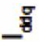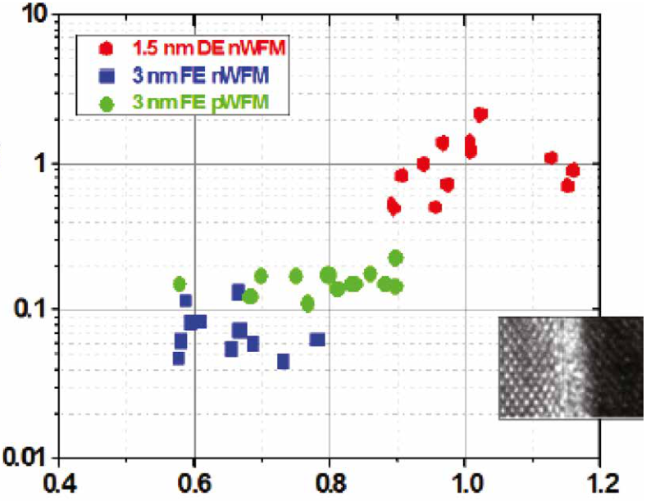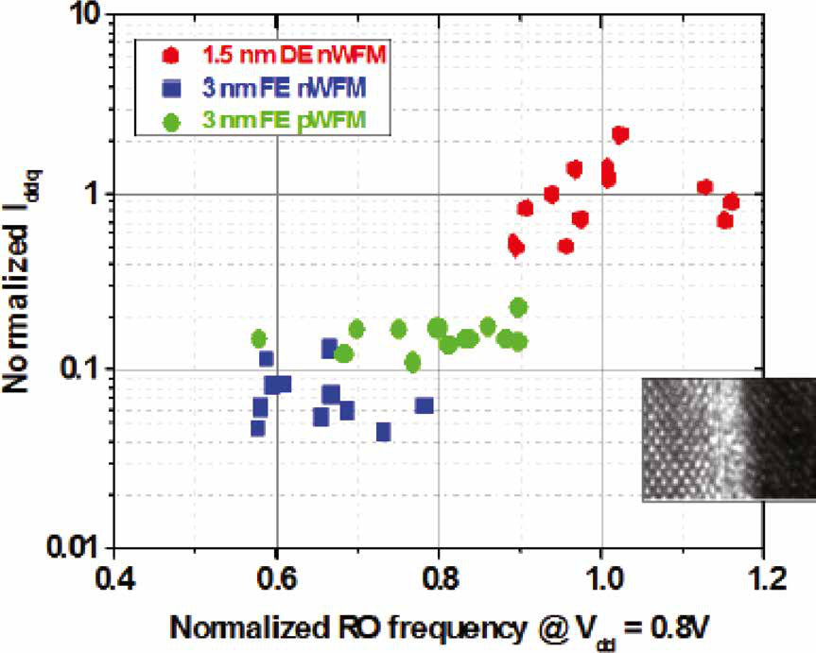

|  |
| --- |
|  |

**Figure 21. HfOx-based FE embedded**   
**SRAM in 14 nm FinFET technology shows 10× less leakage (blue compared to red data points) due to improved short chan-**

Assuming the challenges described in the previ-ous paragraphs can be overcome, *FerroElectronics*, as an ultralow-power technology platform, will ena-ble a new class of microelectronics. *FerroElectronics* being compatible with advanced technology nodes enables *intermittent* and *instant* computing and pro-vides a path to do analog in-memory processing as well as various lower energy mixed signal comput-ing approaches like the *RL* example discussed in the “Technology-assisted algorithmic approaches for small system AI” section. *FerroElectronics* enables technology-based algorithms for more efficient com-puting. This FE -based technology and its components (that constitute *FerroElectronics*) enable directly map-ping certain algorithms into hardware (examples of analog or mixed signal computing) to achieve improved energy efficiency (from a combination of technology and algorithm and eNVM capability).

**nel effects (SCE) [53].**  Moreover, even the current generation of ML- and

NN- (DNNs, CNNs, etc.) based AI solutions (and their

in [53]. Figure 21 shows that eSRAM leakage can be reduced by >10× using FE-based transistors [53].

In addition, HfOx-based FE transistors have improved analog and mixed signal properties as shown in Figure 22 [54]. The shorter channel tran-sistor has a better analog behavior which allows for improved analog transistor scaling (and thus area reduction of the analog circuits). A higher current is achieved at lower voltage. The transis-tor output characteristic is flatter, resulting in a better output resistance and hence a better gain. This enables improved FE-based analog devices for mixed signal.

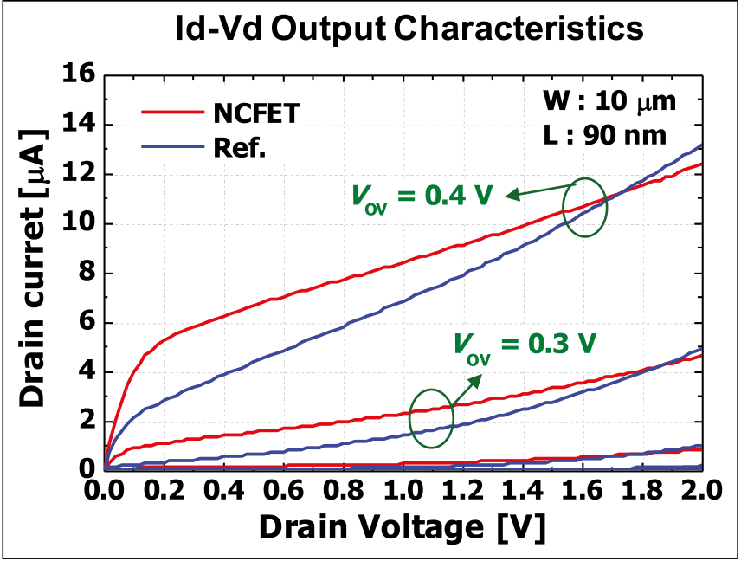

**Figure 22. HfOx-based FE NCFET with improved flatter *I*D versus *V*D transistor output characteristic I–V curve [54].**

known algorithms) on digital CMOS, if ported to an FE-based low-voltage technology platform, will enjoy improved energy efficiency. This technology (*FerroE-lectronics*) will be essential for future EI IoT devices to reach their fullest potential.

System integration and scaling   
 Even though we introduced a new class of elec-tronics enabling *intermittent* and *instant* computing, we are not claiming that it will be practical to integrate all hardware components for the smart IoT devices on one piece of Silicon (i.e., being monolithic). System embedded in a Package (SeP), which refers to creating a system by embedding multiple components in one package using fan-out technology (low-cost 2.5D), will provide a cost-effective path for future system scaling. Therefore, heterogeneous integration (HI) is another critical component of making smart IoT devices real, see Figure 23 [3], [4], [19]–[21]. Other examples of HI are captured in references [19]–[24], including TSMC’s InFO, HRL’s solution and Deca’s M-series; and Intel’s EMIB approach for HI. The ultimate HI is in the CHIPS program where HI can deliver on both high-performance computing and more advanced applications [19], [55]. EI eventually will benefit from CHIPS-style HI with maturity and cost reduction.

Research and development will continue for system miniaturization and scaling [4]. However, the focus for EI should be on developing capabilities like effec-tive *intermittent* and *instant* computing on advanced

Authorized licensed use limited to: Georgia Institute of Technology. Downloaded on April 23,2021 at 20:05:39 UTC from IEEE Xplore. Restrictions apply.

**Figure 23. The concept of SeP for the best in class heterogeneously integrated (HI) pieces of silicon (and other semiconductors) in an advanced 2.5D fan-out package, A cost-effective SeP by Cypress/Deca [4] and for more advanced applications the HI DARPA CHIPS program solution [19].**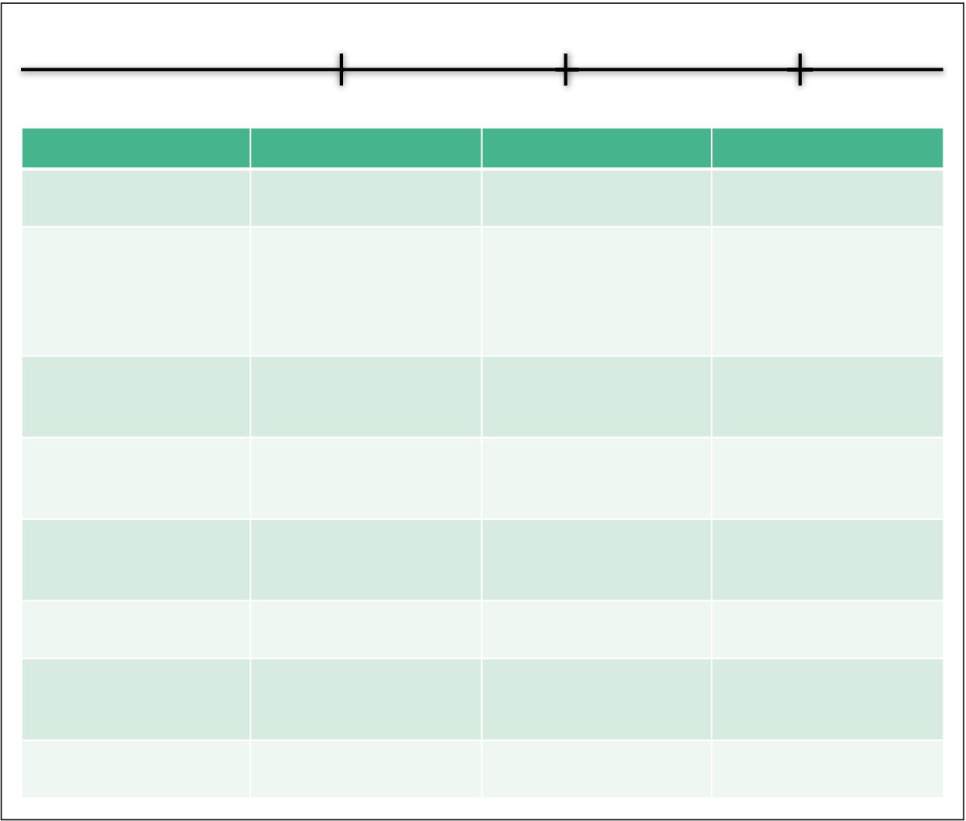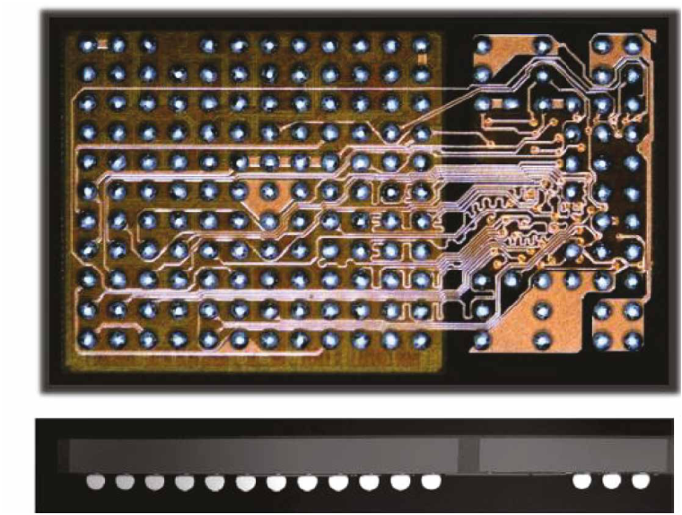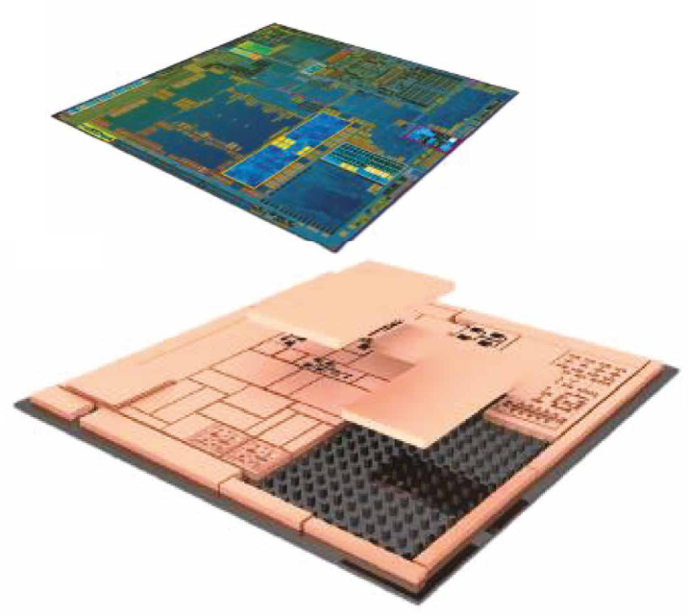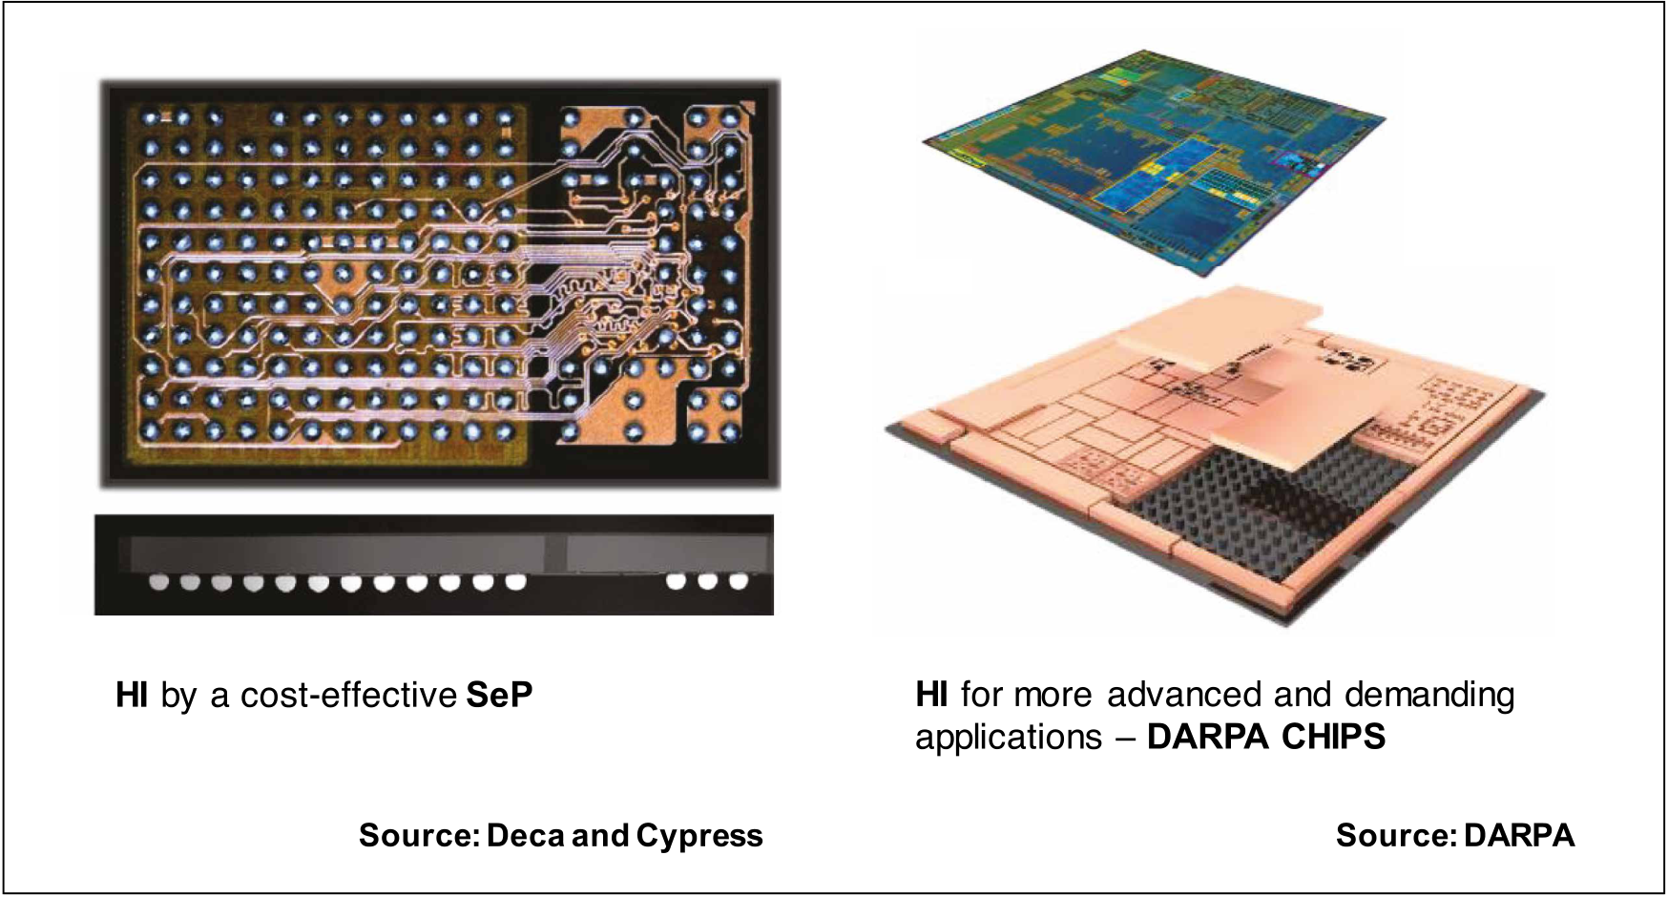

technology nodes (and hence performing responsive *instant* real-time computing at the edge) and utilizing

clever heterogeneous integration as opposed to min-iaturization per se. The need for continual cost reduc-tion (an EI equivalent Moore’s Law) will drive

|  |  |  |  |  |
| --- | --- | --- | --- | --- |
| # of devices | 1010 | 1011 | 1012 | the miniaturization once capabilities have |
| been developed. The cost reduction of devel- |
| time | today | tomorrow | future |
| oped capabilities will help adopting more |
| **Vectors** | **Today** | **State-of-the-art** | **Vision of EI** | pervasive smart applications; one of the paths |
| Smartness & Cost | Sensors, Nodes, | Local intelligence, | “EI”; Performance at | on the march toward a trillion IoT devices. |
| Trade-off | Cost for Performance | Semi Intelligent | minimized cost & power |
| Communications; | BLE + Duty Cycling | Ant-Size Low-Power | Context aware and | Future directions |
| Radio; RF, … | E/b & BW limits | Radios, E/b, BW | intelligent; SDR; Burst; |
| Asym.; RF; NB-IoT; 5G; |
| Computing | MCU; ARM-M Cores; | CPU; Accelerators; ML; | Range; Spectrum; | In this article,various aspects of the EI |
| E/info (pJ/information) |
| vision (the ability to analyze data at the point |
| *Instant* computing; |
| Memory; eNVM | CY PSoC | GPU; Ref: IEDM 2016 | *Intermittent* computing; | of data collection) were discussed. EI capabil- |
| Algorithmic approach; |
| Charge-Trap: FG, | Scaled FG & SONOS; | ity will serve as a catalyst to enable the vision |
| FE based lowest - |
| Architecture | SONOS; SRAM | STT-MRAM, SRAM | Energy eNVM and | of a trillion interconnected IoT devices, thus |
| eSRAM; TCAM |
| Chip, SoC, Sensors; | Specialization; Multi | becoming the next driver of the semiconduc- |
| Near memory and |
| System | e.g. Ag system, Nest | cores; Multi-die; In- | In-memory processing; | tor industry. For EI to become a reality the IoT |
| sensor processing | Analog; Neuromorphic |
| Energy & Power | Battery; Harvesting; | Battery; Harvesting; | Energy scavenging; | devices will have to operate in an environment |
| Management, Analog | Super-Capacitor | Super-Capacitor | *Intermittent* energy | where energy is scarce and its sources *inter-* |
| Process Technology | Mature 0.13um; $/wfr; | 55nm/40nm ULP; $/ Tr | Adv.; 10nm, 14nm, |
| Sub-Vt Operation | 28nm HKMG + eNVM | 16FFC, 22FDSOI, | *mittent*. By analyzing the data locally instead |
| Integration & Advanced | 22FFL; eNVM; $/Tr |
| of sending raw data to the Cloud for analy- |
| Package & Board | Hetero; SiP; Multi-Chip |
| Heterogeneous |
| Packaging | FOWLP | Integration (HI); SeP | sis, energy use can be minimized. Ultralow |

power, intelligent, context-aware radios oper-

**Figure 24. Table summarizing today’s status and the short and long term future directions for the required research vectors, creating the path for EI and enabling a trillion smart and efficient IoT devices.**

ating in burst mode sending aggregated data packages combined with *instant*computing and further in the future *intermittent*comput-ingusingtechnology-influenced algorithmic

Authorized licensed use limited to: Georgia Institute of Technology. Downloaded on April 23,2021 at 20:05:39 UTC from IEEE Xplore. Restrictions apply.

approaches will enable autonomous EI IoT devices to [11] *D60*, in *DARPA 60th Anniv. Conf. Proc.*, National

operate with scavenged energy that has been tempo- Harbor, MD, 2018.

rarily stored at the IoT device. *FerroElectronics* based on HfOx-based FE transistors (and electronic-based collateral components) provide both the energy breakthrough needed and in-memory processing capability to go after the next wave of future algo-rithms (e.g. for in-field learning), which will allow AI

[12] C. Wadia et al., “Resource constraints on the battery energy storage potential for grid and transportation applications,” *J. Power Sources*, 2011.

[13] A. Colin et al., “A reconfigurable energy storage   
architecture for energy-harvesting devices,” in *Proc. 2018 Archit. Support Program. Lang. Operat. Syst.*, 2018.

at the EI IoT device. [14] J. Howard et al., “A 48-core IA-32 processor in 45 nm

**RathERthanREstatIng** the points discussed in this article, we will leave the readers with the table shown in Figure 24: mapping the state of today, tomorrow, and the day after tomorrow, capturing some of the critical research vectors for EI. What has been mapped in this article allows the march from ~1-W edge IoT devices (e.g., today’s mobile phones and smart watches) to 1-mW EI systems (discussed in this article) and per-haps one day 1-µW small AI IoT devices. 

Acknowledgments   
 The authors thank Arijit Raychowdhury, Amin Arbabian, Sayeef Salahuddin, Tom Lee, Suman Datta, Shreyas Sen, Kaushik Roy, Wally Rhines, Simon Segar, and TJ Rodgers for their valuable discussions.

 References  
 [1] K. Ashton, “Procter & Gamble (P&G),” 1999. [Online].

Available: https://www.rfidjournal.com/articles/view?4986

[2] K. Pister, “Smart DUST.” [Online]. Available: https://

CMOS using on-die message-passing and DVFS for performance and power scaling,” *J. Solid-State Circ.*, 2011.

[15] V. Peng, “Keynote Talk,” in *Hot Chips 2018*, Cupertino, CA, 2018.

[16] S. Paul et al., “An energy harvesting wireless sensor node for IoT systems featuring a near-threshold   
voltage IA-32 microcontroller in 14nm tri-gate CMOS,” in *VLSI Circ. Symp.*, 2016.

[17] T. Karnik et al., A cm-scale self-powered intelligent and secure IoT edge mote featuring an ultra-low-power SoC in 14nm tri-gate CMOS,” in *Int. Solid-State Circ. Conf.*, 2018.

[18] A. Amravati et al., “A 55nm time-domain mixed-signal neuromorphic accelerator with stochastic synapses and embedded reinforcement learning for autonomous micro-robots,” in *Int. Solid-State Circ. Conf.*, 2018.

[19] “DARPA CHIPS Program,” in *DARPA ERI Summit*  *2018*, San Francisco, CA, 2018.

[20] “DARPA DAHI Program,” in *DARPA ERI Summit 2018*,

people.eecs.berkeley.edu/~pister/SmartDust/ San Francisco, CA, 2018.

[3] A. Keshavarzi, “Edge Intelligence,” in *Stanford Symp.*, Stanford, CA, Spring 2018.

[4] A. Keshavarzi, “Embedded systems and innovative

[21] B. Rogers et al., “Implementation of a fully molded fan-out packaging technology,” in *IWLPC*, 2013.

[22] J. Sun, “Scaling and collaborative open innovation,” in

technologies for IoT applications,” presented at *VLSI Technol. Symp.*, 2013.

IEDM, 2016. [23] C. Liu et al., “High-performance integrated fan-out

[5] T. Lee, “IoE: Internet of everything,” in *Stanford Symp.*, Stanford, CA, Spring 2018.

[6] A. S. Rekhi and A. Arbabian, “A 14.5 mm2, 8 nW, -59.7 dBm-sensitivity ultrasonic wake-up receiver for power-, area-, and interference-constrained applications,”in *Int. Solid-State Circ. Conf.,* 2018.

[7] M. Tabesh et al., “A power-harvesting pad-less mm-sized 24/60GHz passive radio with on-chip antennas,” in *VLSI Circ. Symp.*, 2014.

[8] W. Rhines, “Keynote Talk,” in *DARPA ERI Summit*  *2018*, San Francisco, CA, 2018.

[9] M. Son, “CEO of Softbank Keynote Talk,” in *ARM*  *Technol. Conf.*, Santa Clara, CA, 2016.

[10] R. Kurzweil, *The Singularity is Near.*

wafer level packaging (InFO-WLP): Technology and system integration,” presented at IEDM, 2012.

[24] S. Chennupaty, “Thin and light high performance graphics,” in *Hot Chips 2018*, Cupertino, CA, 2018.

[25] N. Cao et al., “Self-optimizing IoT wireless video sensor node with in-situ data analytics and context-driven   
energy-aware real-time adaptation,” in *TCAS*, 2017.

[26] S. Sen, “Context-aware energy-efficient communication for IoT sensor nodes,” in *DAC*, 2016.

[27] “DARPA N-ZERO Program,” in *DARPA ERI Summit*  *2018*, San Francisco, CA, 2018.

[28] R. Merritt, “Bluetooth chip needs no battery – Atmosic,” *EETimes*, Oct. 2018. [Online]. Available: [https://www.](https://www.eetimes.com/document.asp?doc_id=1333889)

[eetimes.com/document.asp?doc_id=1333889](https://www.eetimes.com/document.asp?doc_id=1333889)

Authorized licensed use limited to: Georgia Institute of Technology. Downloaded on April 23,2021 at 20:05:39 UTC from IEEE Xplore. Restrictions apply.

[29] A. Keshavarzi et al., “Intrinsic leakage in low power deep submicron CMOS ICs,” *ITC*, 1997.

[30] A. Keshavarzi et al., “Architecting advanced   
technologies for 14nm and beyond with 3D FinFET transistors for the future SoC applications,” invited, presented at IEDM, 2011.

[31] E. Gousev, “Always-on vision becomes a reality,”   
 presented at the 2017 Embedded Vision Summit, 2017.

[32] S. Tsuda et al., “First demonstration of FinFET   
split-gate MONOS for high-speed and highly reliable embedded Flash in 16/14nm-node and beyond,” presented at IEDM, 2016.

[46] M. Trentzsch et al., “A 28nm HKMG super low power embedded NVM technology based on ferroelectric FETs,” presented at IEDM, 2016.

[47] M. Jerry et al., “Ferroelectric FET analog synapse for acceleration of deep neural network training,” presented at IEDM, 2017.

[48] K. Ni, J. A. Smith et al., “SoC logic compatible multi-bit FeMFET weight cell for neuromorphic applications,” presented at IEDM, 2018.

[49] T. Yamaguchi et al., “Highly reliable ferroelectric Hf0.5Zr0.5O2 film with Al nanoclusters embedded by novel sub-monolayer doping technique,” presented at

[33] T. Simonite, “Why John Deere just spent $305 million IEDM, 2018.

on a lettuce-farming robot,” *Wired*, Sep., 2017. [Online]. Available: https://www.wired.com/story/why-john-deere- just-spent-dollar305-million-on-a-lettuce-farming-robot/ [34] T. Sunaga and P. Kogge, “A parallel processing   
 chip with embedded DRAM macros,” *J. Solid-State*

[50] K. Ni, B. Grisafe, et al., “In-memory computing primitive for sensor data fusion in 28 nm HKMG FeFET technology,” presented at IEDM, 2018.

[51] S. Salahuddin and S. Datta, “Use of negative   
 capacitance to provide voltage amplification for low

*Circ.*, 1996. power nanoscale devices,” *Nano Lett.*, 2008.

[35] L. Fick et al., “Analog in-memory subthreshold deep neural network accelerator,” *CICC*, 2017.

[36] D. Fick and M. Henry, “Analog computation in Flash memory for datacenter-scale AI inference in a small chip,” in *Hot Chips 2018*, Cupertino, CA, 2018.

[37] J. Lu et al., “A 1 TOPS/W analog deep   
machine-learning engine with floating-gate storage in 0.13μm CMOS,” in *Int. Solid-State Circ. Conf.*, 2014.

[38] Arijit Raychowdhury, “Mixed-signal computing,” in *Stanford Talk*, Stanford, CA, 2017.

[39] D. Silver et al., “A general reinforcement learning algorithm that masters chess, Shogi, and go through self-play,” *Science*, 2018.

[40] M. Davies et al., “Loihi: A neuromorphic manycore processor with on-chip learning,” *IEEE Micro*, 2018.

[41] T. Fujii et al., “New generation dynamically reconfigurable processor technology for accelerating embedded AI applications,” in *VLSI Circ. Symp.*, 2018.

[42] D. Bankman et al., “An always-on 3.8μJ/86%   
CIFAR-10 mixed-signal binary CNN processor with all memory on chip in 28nm CMOS,” in *Int. Solid-State*

[52] J. P. Duarte et al., “Compact models of   
negative-capacitance FinFETs: Lumped and distributed charge models,” presented at IEDM, 2016.

[53] Z. Krivokapic et al., “14nm ferroelectric FinFET   
technology with steep subthreshold slope for ultra low power applications,” presented at IEDM, 2017.

[54] D. Kwon et al., “Improved subthreshold swing and short channel effect in FDSOI n-channel negative capacitance field effect transistors,” *EDL*, 2018.

[55] “DARPA ERI DSSOC Program”, in *DARPA ERI*  *Summit 2018*, San Francisco, CA, 2018.

**Ali Keshavarzi** is a Visiting Research Scholar with Stanford University, Stanford, CA, and works with DARPA as an expert on the Electronics Resurgence Initiative (ERI) and MTO Investor Working Board (IWB). He is also with Leading Edge Research, Los Altos, CA. Keshavarzi has a PhD in electrical engineering from Purdue University, West Lafayette, IN.

**Wilbert van den Hoek** is an Independent

*Circ. Conf.*, 2018. Adviser, a Board Member, and a Principal with

[43] Z. Jiang et al., “XNOR-SRAM: In-memory computing SRAM macro for binary/ternary deep neural networks,” in *VLSI Technol. Symp.*, 2018.

[44] J. Muller et al., “Ferroelectricity in simple binary ZrO2 and HfO2,” *Nano Lett.*, 2012.

[45] J. Muller et al., “Ferroelectric hafnium oxide: A CMOS-compatible and highly scalable approach to future ferroelectric memories,” presented at IEDM, 2013.

Leading Edge Research, Los Altos, CA. van den Hoek has a Doctorandus in chemistry *(cum laude)* from the Rijks Universiteit Utrecht, Utrecht, The Netherlands.

 Direct questions and comments about this article to Ali Keshavarzi, Department of Electrical Engineering, Stanford University, Stanford, CA 94305 USA; [akesh@stanford.edu](mailto:akesh@stanford.edu).

Authorized licensed use limited to: Georgia Institute of Technology. Downloaded on April 23,2021 at 20:05:39 UTC from IEEE Xplore. Restrictions apply.